

FOCUSED PROCESS EVALUATION TO ASSESS THE USEFULNESS AND EFFECTIVENESS OF

A SPANISH LANGUAGE CLINICALTRIALS.GOV PROTOTYPE FOR SPANISH-SPEAKING

CONSUMERS, AND OF ABBREVIATED DISPLAYS OF INFORMATION FOR CLINICAL TRIAL

RECORDS
Health Services Research & Management Group
- Final Report -

02/06/06

Submitted To:

Graciela Rosemblat
Lister Hill National Center for Biomedical Communications (LHNCBC)
The National Library of Medicine (NLM)
National Institutes of Health (NIH)

Submitted By:

BearingPoint, Inc. | Health Services Research & Management Group
1676 International Drive | McLean, VA 22102-4828

I. Authors

This report was prepared by:

Gabrielena Alcala-Levy, Senior Consultant
BearingPoint, Inc. | HSRMG | 1676 International Drive | McLean, VA 22102
T: 617.988.1410 | F: 617.988.0808 | gabrielena.alcala-levy@bearingpoint.com

Sally Crelia, Manager
BearingPoint, Inc. | HSRMG | 1676 International Drive | McLean, VA 22102
T: 703.747.6620 | F: 703.747.8750 | sally.crelia@bearingpoint.com

Monica Sarmiento, Senior Consultant
BearingPoint, Inc. | HSRMG | 1676 International Drive | McLean, VA 22102
T: 703.747.3995 | F: 703.747.8750 | monica.sarmiento@bearingpoint.com

Clara Perry, Senior Management Analyst
BearingPoint, Inc. | HSRMG | 1676 International Drive | McLean, VA 22102
T: 703.747.7703 | F: 703.747.8750 | clara.perry@bearingpoint.com

Raymundo Morales, Management Analyst
BearingPoint, Inc. | HSRMG | 1676 International Drive | McLean, VA 22102
T: 703.747.4635 | F: 703.747.8750 | ray.morales@bearingpoint.com

II. Table of Contents

1.0 Executive Summary 1
Introduction 1
Methodology 1
Main Findings from Usability Testing 2
Main Findings from Type I and Type II interviews 3
Conclusions and Recommendations 3
2.0 Introduction 5
Background 5
Methodology 6
3.0 Findings from Usability Testing 10
Qualitative Findings 10
Quantitative Findings 18
4.0 Findings from Type I and Type II Interviews 22
General Findings 22
Specific Findings from Type I Interviews 22
Specific Findings from Type II Interviews 23
5.0 Conclusions and Recommendations 26
Content of the doclets 26
Comprehension of the prototype 27
Organization of the prototype 28
Search engine 29
Other recommendations 29
6.0 Appendices 33
Appendix A – Screener To Select Participants For Clinical Trials Web Site Usability Study 33
Appendix B – SAHLSA Test 39
Appendix C - Task Scenarios 42
Appendix D – Usability Scripts 46
Appendix E – Performance Data by Task 77

1.0 Executive Summary

Introduction
The Lister Hill National Center for Biomedical Communications of the National Library of Medicine (LHNCBC/NLM) contracted with BearingPoint to conduct formative evaluation (user testing) of the retrieval based system for the Spanish English CLIR based prototype of ClinicalTrials.gov and to determine how well the experimental Spanish-language doclets meet the needs of Spanish-speaking users seeking information about clinical trials.

The BearingPoint team addressed the following primary questions:

- What information do Spanish-speaking users want when seeking information about clinical trials? Is the information provided in the doclets sufficient to convey what the trials are about?
- Do doclets allow users to judge the relevance of studies with respect to specific needs so that they can apply the information they find?
- Are users satisfied with the current design of doclets?
- How do doclets compare with full documents in information seeking (e.g., accuracy in locating relevant studies, ability to grasp the purpose of a study)?
- How frequently are doclet features used (e.g., linked to corresponding English-language document)?
- Are the doclets helpful, concise, and clear?

Methodology
The BearingPoint Project team conducted a total of 36 interviews with 8 different Spanish-speaking population groups. The evaluation consisted of two research approaches:

Hands-on Usability Testing
The project team, in collaboration with LHNCBC/NLM, designed a series of task scenarios to evaluate whether users were able to navigate easily through the site, comprehend the content of the site, and to determine overall how satisfied users were with the clinical trials Spanish-language Web site.

The team followed prewritten scripts to evaluate participants’ experience searching for information and accomplishing tasks. Participants were also asked to discuss areas of confusion, what features they liked and disliked about the site, and what features should be added or removed from the site.

Semi-structured Interviews
The team conducted one-on-one interviews with 16 participants from each of the 8 target groups. Type I Interviews were conducted to assess users' needs and expectations when seeking information about clinical trials in general. Type II Interviews were conducted to reveal how satisfied participants were with the doclets and draw ideas for improvements. The purpose of these interviews was to determine if the doclets were helpful, concise, and clear.

Main Findings from Usability Testing

General Findings
- In general, participants were pleased to learn, and appreciated, that the National Institutes of Health (NIH) had developed information on clinical trials in Spanish. Some participants commented that it is rare to find reliable information on health issues in Spanish.
- Most participants found the site easy to navigate and liked that the search engine was well located and easy to find.
- Several participants commented that the site and the doclets were well translated. A few participants, however, named some places where the translation was not correct (see section on specific findings for interview type II).
- Participants liked that the home page provides several options to find information (i.e. using the search engine, browsing by condition, browsing by sponsor or status and/or using the links at the top of the page).
- In general, participants with lower literacy levels had more difficulty navigating the Web site, using the search engine, and finding the doclets. This may be correlated to lack of Internet experience, however, rather than the design and concept of the CLIR prototype.

Search Engine and Other Features
- In general, participants were satisfied with the search engine.
- Several participants mentioned, however, that some searches returned numerous studies, making it difficult to select a study of their interest.
- Very few participants noticed the button “visualizar estudios seleccionados” (display selected studies).
- The “búsqueda en resultados” (search within results) feature was rarely used for the intended purpose.
- Very few participants used the “mapa geográfico” (map) feature.

Doclets
- Most of the participants had trouble locating information about the purpose of the study.
- Few participants had trouble locating information about the criteria to participate, date, and who to contact if they want additional information about participating in the trial.

Use of Links
- Few participants showed interest in the “Visualizar el estudio completo en inglés” (see the complete study in English) link.
- Participants commonly clicked on the link to Medline plus in Spanish and the related topics and found this link useful.

Main Findings from Type I and Type II interviews
- In general, participants liked that the information provided in the doclets was available in Spanish.
- Most participants found the information in the doclets helpful but not sufficient to completely understand the purpose of the clinical trial and what it entails.
- Almost all of the interviewees found the purpose section incomplete. Many mentioned they would like to see in this section a more detailed description of what the actual purpose and focus of the trial would be, as well as a description of the health condition.
- Several participants mentioned they like that the document was short and easy to comprehend.

Conclusions and Recommendations

Content of the doclets
- Consider adding additional information to help clarify key points. In particular:
- A short description to the purpose section,
- A few lines to help clarify that the length of the study is the same as the length of time a person would be required to participate in the study.

Comprehension of the prototype
- Consider changing the name of the button “búsqueda en resultados” (search within results) to a more descriptive name so users can better understand its purpose. Alternatively, consider adding a brief explanation that the studies are displayed in order of relevance, from most relevant to least, to the search performed.
- Consider adding the definition of clinical trials to the home page.

Organization of prototype
- Consider moving the box “visualizar estudios seleccionados” (see the selected studies) to the top of the page. Alternatively, instruct the user how to advance to the desired doclets (i.e., click on the link or select the desired clinical trials by clicking on the boxes to the left and clicking on “visualizar estudios seleccionados” at the bottom of the page).
- Consider moving the “search” button in the “detalles de la consulta” (query details) section to the right side of the page, similar to how it appears on the home page.

Search engine
- Consider modifying the search feature to include spell check.

Other recommendations
- Consider adding the names of the states to the “mapa geográfico” (map of locations) section.
- Consider changing the link to NIH health information from the English Web site to the Spanish version (www.salud.nih.gov).
- Consider making the reference to the total number of studies found more noticeable (“XX estudios fueron encontrados” (XX studies found)) so that participants realize they need to scroll to the bottom of the page to view the entire list of studies.
- Consider making the example at the top of the search engine more noticeable (i.e., bigger or bolded). Also, consider changing the name of the city from English to Spanish (i.e., New York to Nueva York).

2.0 Introduction

Background
The Lister Hill National Center for Biomedical Communications of the National Library of Medicines (LHNCBC/NLM) team designed, tested, developed, and evaluated a Spanish-English Cross Language Information Retrieval (CLIR)-based prototype for ClinicalTrials.gov. This prototype allowed Hispanic users to retrieve English-language documents by entering queries in Spanish. However, given that the resulting documents were still in English, the language barrier prevented Hispanic users from taking full advantage of these documents. To remedy this issue, the Consumer Health Research (CHR) team at LHNCBC/NLM not only designed the retrieval system for this Web site but also created abbreviated documents in Spanish called “doclets.”

Doclets provide a subset of the information available in the English-language documents, consisting of data fields that use controlled vocabulary in Spanish: Overall Recruitment Status, Condition(s), Intervention(s), Study Type, Study Design, and select eligibility criteria (Age and Gender).

The LHNCBC/NLM contracted with BearingPoint to conduct formative evaluation (user testing) of the retrieval based system for the Spanish English CLIR based prototype of ClinicalTrials.gov and to determine how well the experimental Spanish-language doclets meet the needs of Spanish-speaking users seeking information about clinical trials. The purpose of conducting user testing of the site was to provide the LHNCBC/NLM team data regarding the target audience’s information needs, their ability to use doclets to obtain relevant information easily and accurately (compared to the full documents in English), and their satisfaction with the doclets.

The BearingPoint team addressed the following primary questions:

- What information do Spanish-speaking users want when seeking information about clinical trials? Is the information provided in the doclets sufficient to convey what the trials are about?
- Do doclets allow users to judge relevance of studies with respect to specific needs so that they can apply the information they find?
- Are users satisfied with the current design of doclets?
- How do doclets compare with full documents in information seeking (e.g., accuracy in locating relevant studies, ability to grasp the purpose of a study)?
- How frequently are doclet features used (e.g., linked to corresponding English-language document)?
- Are the doclets helpful, concise, and clear?

Methodology
The BearingPoint Project team conducted a total of 36 interviews with 8 different Spanish-speaking population groups (see table 1).

Note: M: monolingual, Bi: bilingual, Y: younger, O: older, LM: low/medium, H: high.
Table 1. Research Participants
Audience  Type | Demographics | Literacy  Level | Number of Participants
1 (M/Y/LM) | Monolingual Spanish speakers, ages 20-45 | Low/Medium | 5
2  (M/Y/H) | Monolingual Spanish speakers, ages 20-45 | High | 4
3  (M/O/LM) | Monolingual Spanish speakers, ages 45+ | Low/Medium | 5
4  (M/O/H) | Monolingual Spanish speakers, ages 45+ | High | 4
5  (Bi/Y/LM) | Bilingual Spanish speakers, ages 20-45 | Low/Medium | 5
6  (Bi/Y/H) | Bilingual Spanish speakers, ages 20-45 | High | 4
7  (Bi/O/LM) | Bilingual Spanish speakers, ages 45+ | Low/Medium | 5
8  (Bi/O/H) | Bilingual Spanish speakers, ages 45+ | High | 4
 | Total Participants |  | 36

We leveraged our extensive network of contacts in Hispanic community-based organizations (CBOs) and community centers located in the Washington, DC metropolitan area to recruit representatives of the target audiences. The team developed and followed screening guidelines to recruit a mix of participants varying in age, gender, country of origin, education and literacy level who seek information on the Internet. Screening guidelines may be found in Appendix A.

To determine the literacy level of the participants the team asked potential candidates their last grade completed. In addition, to measure health literacy level, the team administered the Short Assessment of Health Literacy in Spanish-speaking Adults (SAHLSA) in person (a copy of the test can be found in Appendix B) to each of the potential candidates. Based on the answers to these two methods, the team placed participants in two literacy level categories: low/medium and high. In general, participants who scored 46 or less (out of 50) were categorized as having low/medium literacy and those who scored more than 46 were categorized as having high literacy.

The interviews took place from December 5th—December 16th, 2005 at the National Cancer Institute in Rockville, MD and at the BearingPoint offices in McLean, VA. Our four Spanish-speaking researchers conducted the evaluation. Each of the sessions lasted approximately 45-60 minutes and was audio- and videotaped. All participants were compensated for their time. A list of participant demographic information can be found in Table 2.

Table 2. Demographics of participants
Participant  Number | Category of participants |  | Age |  | Gender | Country of Origin | Monolingual/  Bilingual | Score on Health Literacy Test | Education  Level from Screener | BE literacy level classification | Type of Interview | Frequency of Internet usage
1 | Bi/O/LM |  | 45-75 |  | F | Guatemala | Bi | 49 | High school | low/med | U | Every day
2 | M/Y/LM |  | 20-45 |  | M | Guatemala | M | 46 | High school | low/med | U | Sometimes
3 | Bi/Y/H |  | 20-45 |  | M | Colombia | Bi | 48 | College | high | U | Every day
4 | M/O/H |  | 45-75 |  | F | Argentina | M | 50 | College | high | U | Every day
5 | Bi/Y/H |  | 20-45 |  | F | El Salvador | Bi | 46 | College | high | U | Every day
6 | M/O/LM |  | 45-75 |  | M | Peru | M | 49 | High school | low/med | U | Frequently
7 | Bi/O/LM |  | 45-75 |  | F | Chile | Bi | 46 | High school | low/med | U | Sometimes
8 | Bi/O/H |  | 45-75 |  | M | Cuba | Bi | 49 | College | high | U | Frequently
9 | M/Y/H |  | 20-45 |  | F | Mexico | M | 48 | High school | high | U | Frequently
10 | Bi/O/H |  | 45-75 |  | F | Colombia | Bi | 50 | College | high | U | Every day
11 | M/Y/H |  | 20-45 |  | F | Colombia | M | 48 | College | high | U | Frequently
12 | Bi/Y/H |  | 20-45 |  | F | Bolivia | Bi | 50 | College | high | I2 | Every day
13 | M/Y/LM |  | 20-45 |  | M | Mexico | M | 43 | High school | low/med | U | Sometimes
14 | M/O/LM |  | 45-75 |  | F | Peru | M | 46 | High school | low/med | U | Every day
15 | M/Y/H |  | 20-45 |  | F | Chile | M | 49 | College | high | I2 | Every day
16 | M/O/H |  | 45-75 |  | F | Venezuela | M | 49 | High school | high | U | Sometimes
17 | M/Y/H |  | 20-45 |  | F | Peru | M | 48 | College | high | I1 | Every day
18 | M/O/LM |  | 45-75 |  | F | Cuba | M | 45 | College | low/med | U | Sometimes
19 | Bi/Y/H |  | 20-45 |  | M | Peru | Bi | 50 | College | high | I1 | Every day
20 | Bi/Y/LM |  | 20-45 |  | F | Chile | Bi | 46 | Some high school | low/med | U | Every day
21 | Bi/Y/LM |  | 20-45 |  | F | Colombia | Bi | 46 | Some college | low/med | I2 | Every day
22 | M/Y/LM |  | 20-45 |  | F | El Salvador | M | 43 | High school | low/med | I2 | Sometimes
23 | M/Y/LM |  | 20-45 |  | M | Mexico | M | 44 | Some college | low/med | U | Sometimes
24 | Bi/Y/LM |  | 20-45 |  | F | Peru | Bi | 45 | College | low/med | U | Every day
25 | M/O/H |  | 45-75 |  | F | Argentina | M | 50 | Master | high | I2 | Sometimes
26 | Bi/O/H |  | 45-75 |  | M | Colombia | Bi | 49 | Master | high | I1 | Every day
27 | Bi/O/H |  | 45-75 |  | M | Mexico | Bi | 47 | College | high | U | Every day
28 | Bi/O/LM |  | 45-75 |  | F | Bolivia | Bi | 45 | High school | low/med | I2 | Sometimes
29 | M/O/LM |  | 45-75 |  | F | Nicaragua | M | 35 | Some high school | low/med | I1 | Sometimes
30 | M/O/H |  | 45-75 |  | F | Colombia | M | 49 | College | high | I1 | Sometimes
31 | Bi/O/H |  | 45-75 |  | F | Colombia | Bi | 49 | College | high | I2 | Every day
32 | Bi/O/LM |  | 20-25 |  | F | Peru | Bi | 46 | High school | low/med | I1 | Every day
33 | Bi/Y/LM |  | 20-45 |  | M | Bolivia | Bi | 46 | Some college | low/med | I1 | Every day
34 | M/O/LM |  | 45-75 |  | F | Peru | M | 46 | High school | low/med | I2 | Frequently
35 | M/Y/LM |  | 20-45 |  | F | Chile | M | 46 | High school | low/med | I1 | Every day
36 | Bi/Y/H |  | 45-76 |  | F | Venezuela | Bi | 50 | College | high | U | Every day

Note₁: As agreed with the client, the research team interviewed additional participants from audience groups Bi/Y/H and Bi/O/H (in replacement of two participants from groups Bi/Y/LM and Bi/O/LM) after determining participants with higher literacy levels were able to provide better feedback on the usability testing.
Note₂: M: monolingual, Bi: bilingual, Y: younger, O: older, LM: low/medium, H: high.
Note ₃: Frequently: at least once a week but not every day, Sometimes: Less than once a week.

The evaluation consisted of two research approaches:

Hands-on Usability Testing
The project team, in collaboration with LHNCBC/NLM, designed a series of task scenarios to evaluate whether users were able to navigate easily through the site, comprehend the content of the site, and to determine overall how satisfied users were with the clinical trials Spanish-language Web site. The task scenarios used for the hands-on usability testing can be found in Appendix C.

Our research team gave the participants printed copies of the tasks to be completed using the Web site. One of our Spanish-language researchers observed each of the participants, taking notes as they proceeded with each task/scenario while navigating the Web site. Participants were asked to “think aloud” while completing these tasks so that researchers could capture any comments or observations. Participants’ audio and actions on the computers were also recorded, and analyzed at the completion of the research. The usability sessions included 20 participants representing each of the 8 target groups.

The team followed prewritten scripts to evaluate participants’ experience searching for information and accomplishing tasks. Participants were also asked to discuss areas of confusion, what features they liked and disliked about the site, and what features should be added or removed from the site.

Semi-structured Interviews
The team conducted one-on-one interviews with 16 participants from each of the 8 target groups. Type I Interviews were conducted to assess users' needs and expectations when seeking information about clinical trials in general. The team asked general questions regarding the types of information participants would require, or like to see, when looking for information about clinical trials. Eight participants completed this type of interviews.

Type II Interviews were conducted to reveal how satisfied participants were with the doclets and draw ideas for improvements. For these interviews, the BearingPoint researchers provided participants with copies of the doclets to review and comment. The purpose of these interviews was to determine if the doclets were helpful, concise, and clear. In particular, the interviews helped determine whether users were satisfied with the current content of doclets, whether the information provided in the doclets was sufficient to understand what the clinical trials were about, how the doclets compare with the full documents in information seeking, and what additional information should be provided, if any, in the doclets. Eight participants (different from those mentioned above) completed this exercise.

The interview guides for the hands-on usability testing and the one-on-one interviews may be found in Appendix D.

3.0 Findings from Usability Testing

Twenty research participants were given four scenarios, or tasks, to complete. The purpose of the task scenarios was to test the users’ ability to navigate the site and accomplish search tasks easily, quickly, and effectively.

The following represents some of the general and specific findings from the usability research:

Qualitative Findings

General Findings
- In general, participants were pleased to learn, and appreciated, that the National Institutes of Health (NIH) had developed information on clinical trials in Spanish. Some participants commented that it is rare to find reliable information on health issues in Spanish.

“...At first I saw the word clinicaltrials.gov [in English] at the top of the page but then I was glad to see the rest [of the information] was in Spanish”

- Most participants found the site easy to navigate. They liked that the search engine was well located and easy to find.

“…to navigate this Web site all you need to know is how to read and how to use a computer”

“…I like that the search engine is on the home page, that makes the search easier and faster”

- Upon completing the research, many participants asked if this site was available and ready for them to visit. Many thought the site was very interesting and would consider visiting it in the future.

“ this Web site is very interesting and informative”

- Several participants commented that the site and the doclets were well translated. A few participants, however, named some places where the translation was not correct (see section on specific findings for interview type II)
- Participants liked that the home page provides several options to find information (i.e. using the search engine, browsing by condition, browsing by sponsor or status and/or using the links at the top of the page).
- In general, participants with lower literacy levels had more difficulty navigating the Web site, using the search engine, and finding the doclets. This may be correlated to lack of Internet experience, however, rather than the design and concept of the CLIR prototype.

Search Feature
- In general, participants were satisfied with the search engine. In most cases, the search engine returned appropriate results. The engine also allowed users to type in terms in English, with results being displayed in Spanish. However, the search engine did not work well if terms were typed in incorrectly or were not spelled accurately. One participant, for example, typed “tiroide” instead of “tiroides” and the search engine did not return any studies related to the condition.
- Several participants mentioned that some searches returned numerous studies, making it difficult to select a study of their interest. They also commented that the titles of the studies were not organized in a logical way. They suggested organizing the results by categories. For example, studies could be organized by date, age group or by sponsor company.
- While several participants performed combined searches, very few actually noticed the example displayed at the top of the page. For example, when searching for a particular clinical trial in Virginia, participants rarely typed the name of the condition followed by a comma and then by the state (i.e. asthma, Virginia) as provided in the example at the top of the search box. When asked why, participants usually stated they had not noticed the example provided. Some suggested making the example more noticeable (i.e., bigger or bolded).

Participants did not notice this example
Ejemplo: ataque cardíaco, New York
Sugerencias

Other Features
- When prompted to select a specific study from the results page, approximately half of the participants clicked on the link to open a doclet. However, the remainder of the participants checked the boxes to the left of the title of the study and then clicked the button “búsqueda en resultados” (search within results) or “detalles de la consulta” (query details). Very few participants realized that they had to scroll to the bottom of the page and click the button “visualizar estudios seleccionados” (display selected studies) in order to find the doclets. Some of these participants suggested moving the “visualizar estudios seleccionados” box to the top of the page.

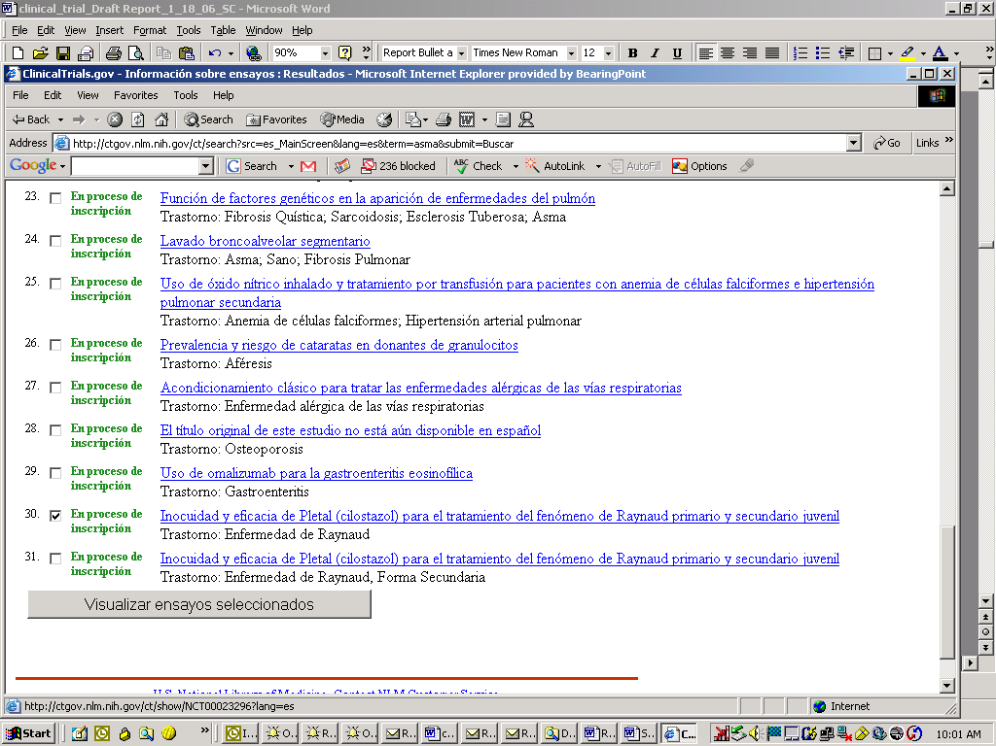
Very few realized they had to click here to view the selected clinical trials

- Those participants who clicked on the “detalles de la consulta” (query details) button were confused by the information displayed and were unclear about what actions they should take. In addition, one participant commented that the “search” button should be on the right side of the page, and not the left This same participant mentioned she got an error message when using the search button of this section (see screenshots below).

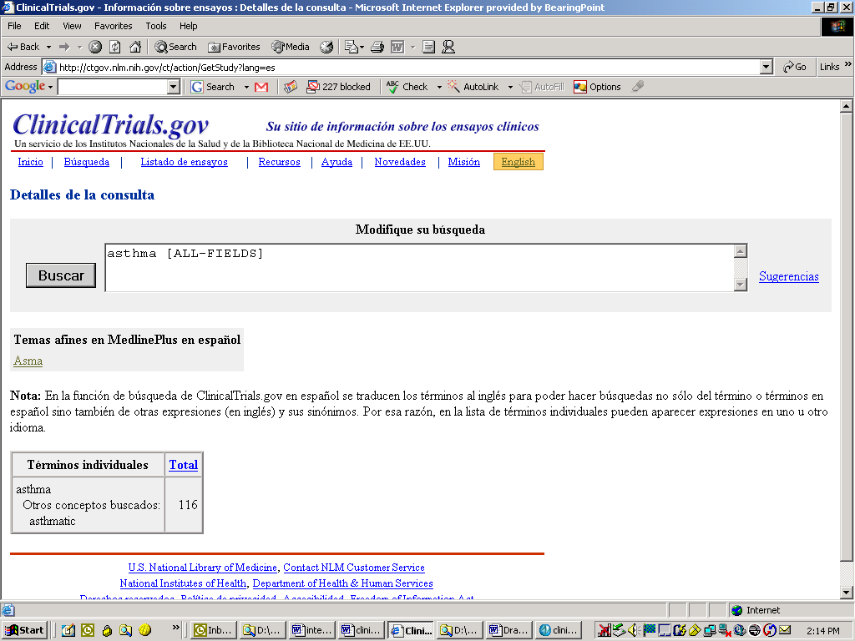
Search button should be on the right hand side and not on the left

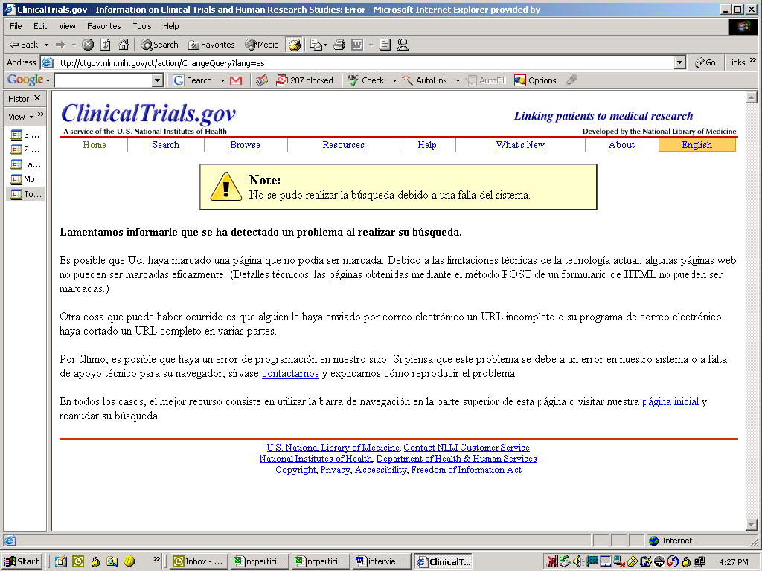
Participant got this error message when using the “Search” button in the “Query Details” section.

- The “búsqueda en resultados” (search within results) feature was rarely used for the intended purpose. None of the participants realized that this feature could be used to narrow the list of results obtained from the search. Several, in fact, mentioned how difficult it was to look for a study of interest among the long list of studies displayed from a search.
- Very few participants used the “mapa geográfico” (map) feature. Those who did commented that it would be easier if the names of the states were written on the map or somewhere on that page.

Doclets - Purpose section
- Most of the participants had trouble locating information about the purpose of the study. Almost all of the participants did not realize that to obtain information about the purpose they had to link to the full study in English. When asked about the purpose, most assumed the information located in the box containing the condition, intervention and phase, provided the only information about the study. A few participants tried to click on the word “Finalidad” (purpose) thinking it was a link.

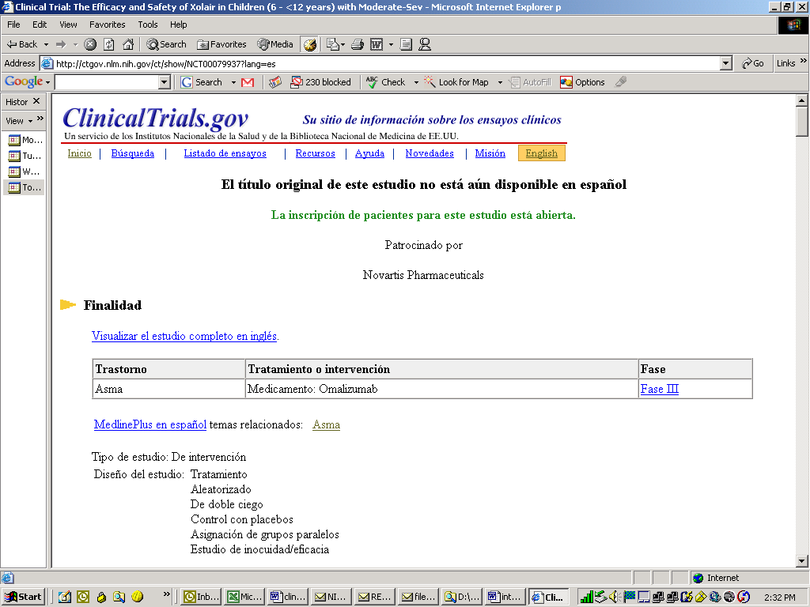
Participants thought this box provided the purpose of the study
Very few used this link

- Almost none of the participants clicked on the link “Visualizar el estudio completo en inglés” (see the complete study in English). When asked why, participants mentioned that even if they noticed the link, it did not catch their attention because they were looking for information in Spanish, not in English.

Eligibility and Contact Information
- Few participants had trouble locating information about the criteria to participate, date, and who to contact if they wanted additional information about participating in the trial.
- About one-quarter of the participants said they were not clear what the section “diseño del estudio” (study design) meant.

Use of Links
- Few participants showed interest in the “Visualizar el estudio completo en inglés” (see the complete study in English) link. Most said they saw it but did not focus on it because it was in English and they were searching for information in Spanish.

- Participants commonly clicked on the link to Medline plus in Spanish and the related topics and found this link useful.

Other Observations
- A few participants suggested adding a brief definition of “clinical trials” to the home page in order to introduce the concept and purpose of the site. Although a more detailed explanation is provided when clicking on links in the “recursos” (resources) section, several suggested a brief introduction up front would be useful.
- One participant noticed that part of the example for completing a combined search was in English, referencing New York instead of Nueva York.

Ejemplo: ataque cardíaco, New York
Sugerencias

- Very few participants noticed that once they completed a search and the resultant titles of the studies were displayed, the total number of studies was referenced at the top of the page. Also, few participants realized they needed to scroll to the bottom of the page to view the entire list of studies.

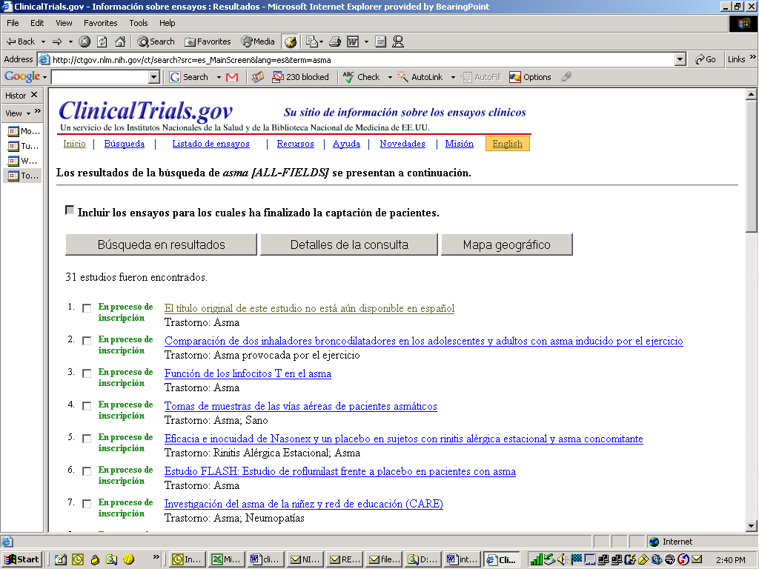
Very few noticed this

- One participant thought that all the studies listed from the result of the search were already completed because of the phrase “XX estudios fueron encontrados” (he/she interpreted “fueron” to mean “completed”. The participant suggested changing that sentence to “XX estudios encontrados”.
- Some participants asked whether the NIH health information link at the bottom of the home page was available in Spanish and, if so, why it was provided in English on this site. Also, two participants mentioned that the name of the two links at the bottom of the home page were in English. They said that if the Web site is in Spanish then all of the information should be in Spanish, not English (see screenshot below).

Why in English?

- One participant performed a search for a study in Virginia and the result showed a study that was actually in New York. As a result, this participant suggested the search engine did not work appropriately.

Quantitative Findings
Appendix E presents detailed performance data by task.

Participants’ abilities to accomplish given tasks varied according to their literacy level, age, and the scenario given. A full description of each task scenario can be found in Appendix C. For the purpose of this report, we classified the completion status of tasks as:

- Completed: the participant was successful in accomplishing the task without any major problem.
- Completed with help: the participant was able to find some of the information but the interviewer intervened so that the task could be completed.
- Partially completed with help: the participant completed parts of the task but was not able to find all of the information requested. Even with the help of the interviewer, the participant could not find all of the requested information. An example of a partially competed task was when one participant was able to find a list of doclets about asthma but was not able to find one about inhalers.
- Not completed: the participant requested termination or the interviewer terminated the task because time limit elapsed or because the interviewer realized the participant was completely off track.

In general, participants with lower education levels had a lower rate of completion. We found that, although most of the participants with lower education had reported previous experience using computers, these participants had more difficulty completing the tasks. Most participants with higher education levels had very high completion rates, particularly those who were bilingual and under 45 years of age (91.7%). Monolingual participants age 45 or older (categories M/O/LM and M/O/H) also had lower rates of completion regardless of their education status (see Table 3). Given that Internet usage tends to be lower among older Hispanic groups, this finding is not surprising.

Table 3. Task Completion Status by Category of Participants
 | Completion rate (%)
Category of participant | Completed | Completed with help | Partially completed with help | Not completed
M/Y/LM | 25.0 | 0.0 | 41.7 | 33.3
M/Y/H | 75.0 | 0.0 | 0.0 | 25.0
M/O/LM | 16.7 | 16.7 | 33.3 | 33.3
M/O/H | 12.5 | 12.5 | 25.0 | 50.0
Bi/Y/LM | 57.1 | 14.3 | 28.6 | 0.0
Bi/Y/H | 91.7 | 0.0 | 8.3 | 0.0
Bi/O/LM | 66.7 | 8.3 | 0.0 | 25.0
Bi/O/H | 50.0 | 37.5 | 0.0 | 12.50
Note: M: monolingual, Bi: bilingual, Y: younger, O: older, LM: low/medium, H: high.

Table 4 shows the overall completion status of the five tasks or scenarios. Task 4 was the task most likely to be completed (i.e., completed or completed with help), followed by tasks 2 and 3. Tasks 1 and 5 had the lowest completion rates, with task 5 having the lowest overall. For tasks 1, most participants were able to find the list of doclets related to asthma but were not able to find a trial specifically related to inhalers.

In general, participants had more difficulty finding specific information on the Web site versus more general information. For example, participants had more trouble fully completing Task 5, which requested participants to find a very specific study on weight loss in Virginia for people between 18 and 65 years old. This suggests that very specific information is not easy to find in the CLIR prototype. Very few participants used the advanced search engine to find this kind of information. Most used a combined search (i.e., typing the health condition and sponsor company) using the regular search engine.

Those who were able to find the list of titles mentioned that it was difficult to find the specific study they were looking for. Few also scrolled to the bottom of the page and thus did not always see the entire list of studies. Some suggested grouping the studies in categories to make the search within the results easier.

Table 4. Task Completion Status by Scenario
 | Task Completion rate (%)
 | Completed | Completed with help | Partially completed | Not completed
Scenario 1 (find a clinical trial related to asthma, particularly related to inhalers) | 52.6 | 5.3 | 15.8 | 26.3
Scenario 2 (find a clinical trial related to breast cancer, sponsored by Abbott Laboratory) | 52.6 | 10.5 | 10.5 | 26.3
Scenario 3 (find information on clinical trials) | 57.9 | 5.3 | 21.1 | 15.8
Scenario 4 (find a clinical trial related to obesity) | 55.6 | 22.2 | 11.1 | 11.1
Scenario 5 (find a clinical trial related to weight loss, taking place in Virginia) | 23.1 | 15.4 | 30.8 | 30.8

Table 5 shows the average time of completion for each of the different tasks. These average times were calculated only for those participants who completed or partially completed the task (i.e., time spent on tasks not completed was excluded from the analysis). Task 5 took the longest average time to be completed, followed by task 2 and 4. Task 2, similar to Task 5, required the participant to find specific information (i.e., a study on breast cancer sponsored by Abbott laboratories), confirming our finding that specific information is not easy to find in the CLIR prototype. Task 4 requested participants to find a doclet on obesity and then information specifically related to that health condition. On average, participants took several minutes to complete this task but were successful in finding the desired information most of the time.

The number of pages accessed in the CLIR prototype ranged from an average of 4.4 (SD=3.6) for task 3 to 10.8 (SD=14.8) for task 5 (see Table 5).

Table 5. Average Completion Time per Scenario (in minutes)
 | Mean | Std dev
Scenario 1 | 3.2 | 1.9
Scenario 2 | 4.0 | 2.8
Scenario 3 | 2.0 | 1.7
Scenario 4 | 3.8 | 1.5
Scenario 5 | 5.6 | 2.4

Table 6 shows the average number of Web pages accessed while completing tasks.

Table 6. Average number of pages accessed- CLIR prototype
 | Mean | Std dev
Scenario 1 | 8.1 | 5.8
Scenario 2 | 8.5 | 4.8
Scenario 3 | 4.3 | 3.6
Scenario 4 | 5.9 | 2.8
Scenario 5 | 11.3 | 14.8

4.0 Findings from Type I and Type II Interviews

Type I and II Interviews were designed to determine whether the experimental Spanish-language doclets meet the needs of Spanish-speaking users when seeking information about clinical trials. These interviews allowed us to collect information on the target audience’s information needs, their ability to use doclets to find information necessary to better understand what the clinical trial is about, and their satisfaction with the doclets.

General Findings
- We found that participants felt that the current doclets (doclets without the purpose section) were a good starting point for finding information about clinical trials. However, most of the participants (close to 90%) concluded that they needed additional information to understand better what the clinical trial was about and what it entailed. The aspects most commonly mentioned included the lack of a clearly defined and explained purpose and the lack of information detailing the benefits and risks of the trial in question.
- The perception about the doclets improved once participants were presented with a doclet with a briefly defined purpose section. About half of them said that they understood better what the study was about and half said they did not find the purpose section that helpful, and that it did not provide enough information to understand what the studies were about. When explained that the two possible options for presenting the information related to the purpose of the study included either 1) no explanation at all in the purpose section but a link to the full study in English, or 2) a short explanation of the purpose in Spanish with a link to the full study in English, all of the participants said they preferred a short explanation in Spanish, even if it was brief.

Specific Findings from Type I Interviews
Type I Interviews were designed to help determine what information Spanish-speaking users would like to find when seeking information about clinical trials, and to determine if the current information provided in the doclets met their expectations.

These interviews were divided into two parts. During the first part, the researchers asked participants what kind of information they would like to find if they were searching for information about clinical trials. During the second part, researchers showed participants two groups of different doclets (each group containing two doclets, one without a purpose section and one with a brief paragraph) along with the corresponding English full text clinical trial document. Participants were asked which of those documents contained the information they most desired.

The following illustrates the kind of information participants mentioned they would like to find:

Most frequently mentioned

- Benefits and risks of participating.
- Information provided in simple terms without too much medical terminology/Purpose of the study in very simple terms.
- Length of time the study will last.
- The type of treatment provided (i.e. medicines).
- The name of the sponsor company to evaluate how reliable the study is.

Least frequently mentioned

- Location of the clinical trial.
- Number of people that will participate.
- The phase in which the study is at the moment, whether experimental or not.
- The kind of assistance provided while participating in the study (i.e. transportation, living arrangement if necessary).
- Probabilities of improving medical condition as a result of participating in the trial.

Most participants found that the doclets were a good starting point but that they would like to see:

- A more detailed purpose section so that they could better understand what the clinical trial was about. Participants preferred to have more explanation in the purpose section and less information related to other aspects of the study (i.e., type of study, design of the study and the box right below the purpose section).
- A section explaining benefits and risks.
- A section providing information about the length of time a person would be required to participate.

Specific Findings from Type II Interviews
Type II Interviews were designed to evaluate the content of the doclets. The purpose of these interviews was mainly to determine if the information provided was sufficient to understand what the trials were about and if the doclets were helpful, concise, and clear.

In general, participants liked that the information provided in the doclets was in Spanish. Most participants commented that it is important for Spanish-speakers to have access to health and health related information in Spanish as many are not able read, or understand, information in English.

Specific findings included:

Is the information sufficient?
- Most participants found the information in the doclets helpful but not sufficient to completely understand what the clinical trial was about and what it entailed. Most said they would like to see more information about the purpose of the study, benefits and risks of participating, the specific activities involved in participating, and how and how long their participation would be.
- Almost all of the interviewees found the purpose section incomplete. Many mentioned they would like to see in this section a more detailed description of what the actual purpose and focus of the trial would be, as well as a description of the health condition.

Are the doclets helpful, concise, and clear?
- Several participants mentioned they liked that the document was short.
- Most participants found the information provided in the doclets was easy to comprehend. Only a few words were identified as difficult to understand:
- Trastornos
- Inocuos
- Inmunoterapia
- Hiperaldosteronismo
- Serotonina
- Paroxetina
- Calcio plaquetario
- Asignación factorial

Additional things that participants would like to see
Participants suggested adding

- More information about the kind of treatment they will receive if participating in a clinical trial. Several mentioned they would like to know whether or not they would be administered any medications and, if so, what kind.
- A section about benefits and risks of participating. Several participants mentioned that they would like to see the benefits and risks of the study itself. Even though they know there is a section on benefits and risks in general, they would still like to see this information in the doclets.
- Incentives, if any, to participate in a study (i.e., remuneration to participate).
- Length of time required to participate.

Other observations
- One participant mentioned it was not clear what “estudio de observación” was.

“...aren’t all studies observational studies?”

- One participant mentioned that the translation for “this study has been completed” was wrong. The participant said that “Inscripción de paciente finalizada” is not the same as “this study has been completed.”

5.0 Conclusions and Recommendations

As mentioned previously, most participants stated they were pleased to learn that NIH had created a Spanish language Web site about clinical trials and expressed interest in visiting this site in the future. Many, however, suggested there were several aspects of the site and the doclets that could be improved. Based on the findings from each of the research methodologies described above, the BearingPoint team recommends the following changes:

Content of the doclets
- Consider adding a short description to the purpose section.
- Even though participants said that a short description was not sufficient to understand the full purpose of a study, having some information about the purpose was highly preferred to not having any information at all. Furthermore, we found that when the short description was not provided, participants became confused about the purpose of the study. As a result, most participants inaccurately assumed the purpose could be inferred from the box below the purpose section.

“…the doclets without the purpose section gives the impression of this study being a program to lose weight whereas the one with the purpose section seems more to be about research taking place”

- Whenever possible, consider adding a few lines to help clarify that the length of the study is the same as the length of time a person would be required to participate in the study. For example, “tiempo requerido para participar en el estudio” (length of time required to participate) right below “fecha de inicio del estudio” (start date of the study).
- When asked what was missing in the doclets, many participants said they wanted to know how long they would be required to participate in the study if they wanted to do so. Most did not consider the start and end date as the required time for their participation.

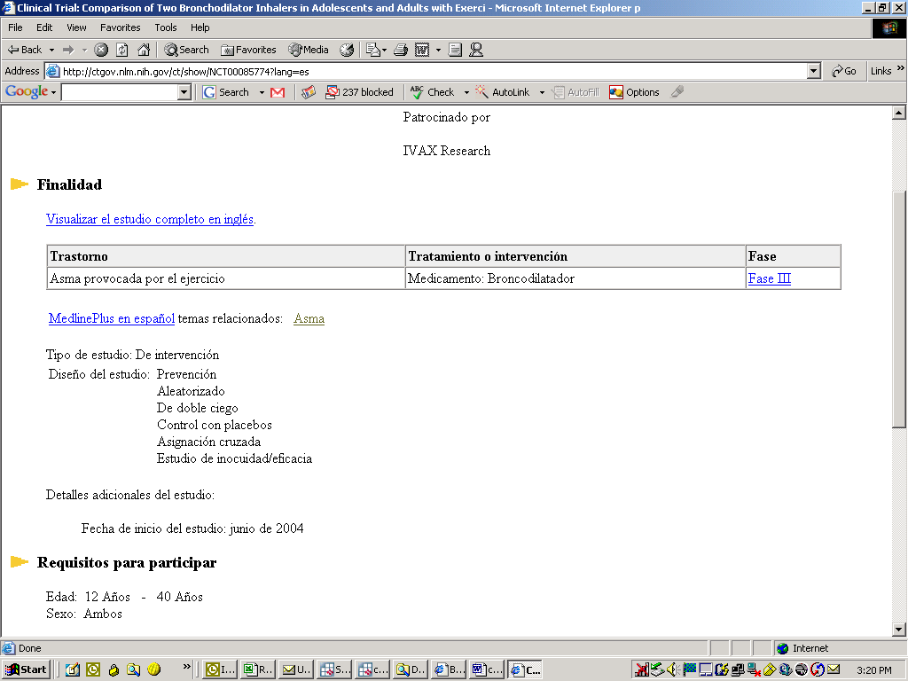
Insert information about length of time required to participate
Add short definition of the purpose in here

Comprehension of the prototype
- Consider changing the name of the button “búsqueda en resultados” (search within results) to a more descriptive name so users can better understand its purpose. Alternatively, consider adding a brief explanation that the studies are displayed in order of relevance, from most relevant to least, to the search performed.
- Several participants mentioned how difficult it was to look for a particular study of interest among the long list of studies often returned from a search. Most participants thought that the list of returned studies was not organized in a logical way.
- Consider adding the definition of clinical trials to the home page.
- Many participants suggested adding a brief definition of “clinical trials” to the home page would help introduce the concept of clinical trials and the purpose of the site.

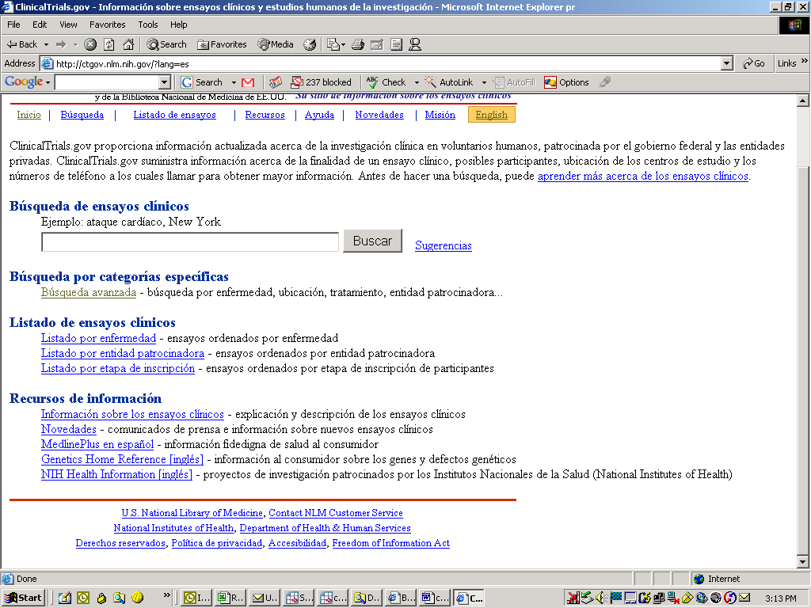
Consider adding the definition of clinical trials here
Organization of the prototype
- Consider moving the box “visualizar estudios seleccionados” (see the selected studies) to the top of the page. Alternatively, instruct the user how to advance to the desired doclets (i.e., click on the link or select the desired clinical trials by clicking on the boxes to the left and clicking on “visualizar estudios seleccionados” at the bottom of the page).
- Very few participants realized that they had to scroll to the bottom of the page and click the button “visualizar estudios seleccionados” (display selected studies) to actually get to the doclets. Several participants assumed they had completed their search once they had arrived to the page listing the clinical trials that had met the search criteria and, as a result, never advanced to the actual doclets.
- Consider moving the “search” button in the “detalles de la consulta” (query details) section to the right side of the page, similar to how it appears on the home page.
- Several participants commented they were not accustomed to seeing the search button to the left of the search box and found it confusing seeing it on that side.

Search engine
Consider modifying the search feature to include spell check.

- As noted previously, the search engine, in general, worked well for participants when searching for information on particular clinical trials. However, the search feature did not work well if terms were typed in incorrectly or were not spelled accurately. In order to better address the needs of persons with lower education or literacy levels, the site should allow for mistakes in spelling and/or typing of search terms. One option would be to consider using a search feature similar to the one found in the English version of this Web site that offers alternatives to users who misspell words.

Consider adding a spell check feature like this

Other recommendations
- Consider adding the names of the states to the “mapa geográfico” (map of locations) section.
- Participants mentioned that it would be easier to find particular states if the map included the names.

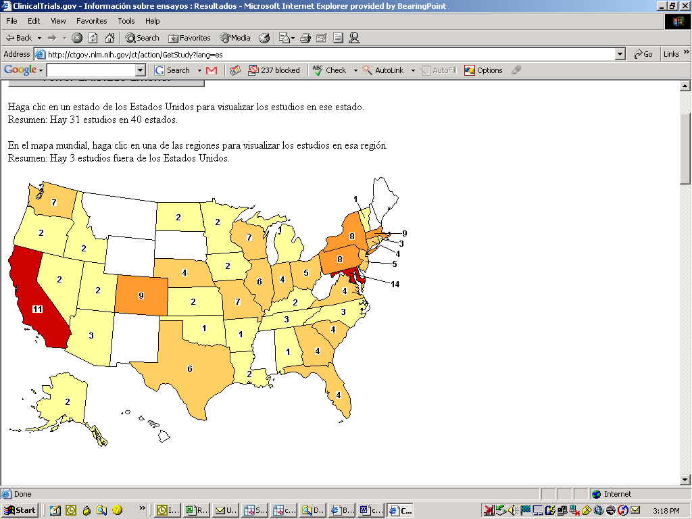
Add names to states here

- Consider changing the link to NIH health information from the English Web site to the Spanish version (www.salud.nih.gov).
- Some participants asked whether the NIH health information link at the bottom of the home page was available in Spanish and, if so, why it was provided in English on this site.

Change this link to the Spanish version (www.salud.nih.gov)

.
- Consider making the example at the top of the search engine more noticeable (i.e., bigger or bolded). Also, consider changing the name of the city from English to Spanish (i.e., New York to Nueva York).
- While several participants performed combined searches, few actually noticed the example displayed at the top of the page making it more difficult to find the information desired. Those who did notice the example, mentioned that part of it was in English and not in Spanish.

Make this example more noticeable and change New York to Nueva York
Ejemplo: ataque cardíaco, New York
Sugerencias

- Consider making the reference to the total number of studies found more noticeable (“XX estudios fueron encontrados” (XX studies found)) so that participants realize they need to scroll to the bottom of the page to view the entire list of studies. Alternatively, consider adding a brief explanation that users should scroll to the bottom of the page in order to see the entire list or results (i.e. “to view the entire list of studies, scroll to the bottom of the page).
- Few participants noticed that once they completed a search and the resultant titles of the studies were displayed, the total number of studies is referenced at the top of the page. Also, few realized they needed to scroll to the bottom of the page to view the entire list of studies.

Make this reference more noticeable
6.0 Appendices

Appendix A – Screener To Select Participants For Clinical Trials Web Site Usability Study

Participants: General Hispanic public who seek health information, in Spanish, on the Web
Location: National Cancer Institute lab
Date: December 6-December 8/December 12-14 (see Appendix A)

Project: Focused Process Evaluation To Assess The Usefulness And Effectiveness Of Experimental Displays Of Information About Clinical Trials For Spanish Speaking Consumers

[Note: Please recruit a total of 36 respondents (16 of the respondents will complete the 1 on 1 interviews and the other 20 will complete the usability testing).

this recruiting should be conducted in spanish to ensure potential respondents are fluent in and speak spanish as their primary language.]

Criteria (see attached table for specific selection criteria):
- Men and Women [as close to 50% of each as possible]
- Ages 20-45 [18 participants]; older than 45 [18 participants]
- Monolingual Spanish-speakers [18 participants] and Bilingual Spanish Speakers [18 participants]
- Participants with a range of education levels:
- Low : 9th-12th grade (10 participants),
- Medium: high school graduate, GED or technical/trade school and/or some college (10 participants)
- High: college graduate, or graduate courses or degree (16 participants)
- Participants should have searched for health information, in Spanish, from at least 1 Spanish language Web site in the last 6 months
- Participants must regularly use the Internet to search for information. All must be comfortable using a mouse to scroll up and down Web pages and click for more information.
- All possible participants will be administered a test to measure health literacy (see Appendix B)

Table 1. Selection of Research Participants
Audience | Demographics | Literacy | Number of Participants
1 | Monolingual Spanish speakers, ages 20-45 | Low/Medium | 5
2 | Monolingual Spanish speakers, ages 20-45 | High | 4
3 | Monolingual Spanish speakers, ages 45+ | Low/Medium | 5
4 | Monolingual Spanish speakers, ages 45+ | High | 4
5 | Bilingual Spanish speakers, ages 20-45 | Low/Medium | 5
6 | Bilingual Spanish speakers, ages 20-45 | High | 4
7 | Bilingual Spanish speakers, ages 45+ | Low/Medium | 5
8 | Bilingual Spanish speakers, ages 45+ | High | 4
 | Total Participants |  | 36

Hello. My name is _____ and I’m calling from [BearingPoint], a local research firm. We are conducting a study for the National Institutes of Health (NIH) and would like to see if you would be interested in participating. If you are interested and you qualify for this study, you might be asked to go to a research facility to give your opinions in a [one-on-one] discussion that would last no more than 1 hour. You will be compensated for your time. I want to assure you that we are not trying to sell you anything – we are only interested in getting your opinions about some information the NIH has developed in Spanish. If you participate, your comments and opinions will help us greatly toward understanding how to improve the information to make sure it is as useful and helpful as possible.

[Record respondents’ sex.]
_______ Female
_______ Male

1. What languages do you speak?
______ Spanish only [Go to question 4]

______ English only [Thank respondent for their time and end call]

______ Spanish and English [Go to question 2]

2. Which is your preferred language? (Do you mainly speak Spanish or English in your home?)
______ Spanish [Go to question 3]

______ English [Thank respondent for their time and end call]

3. Do you prefer to read information, about health or current events, for example, in Spanish or in English?
______ In Spanish [Go to question 4]

______ In English [Thank respondent for their time and end call]

4. Do you use the Internet?
______ Yes [if yes, go to question 5]
______ No [If no, thank respondent for their time and end call]
5. How often do you use the Internet?
______ Frequently (at least once a week)
______ Sometimes (less than weekly)
______ Never [if never, thank respondent for their time and end call]

6. Are you comfortable using a standard computer set up, and a standard computer mouse to navigate through Web sites by scrolling and clicking on information?
_____ Yes [Continue to next question.]
_____ No [If no, thank respondent for their time and end call]
7. Have you ever searched for health information, in Spanish, for yourself, a friend, or a family member, on the Internet?
______ Yes [if yes, go to the next question]
______ No [If no, thank respondent for their time and end call]
8. How long ago did you search for this information?
______ Very recently (within the past few weeks)
______ Fairly recently (since May of this year)
______ Over 1 year ago [Thank respondent for their time and end call]
9. On which site did you search for Spanish language health information? What was the topic? [Recruiter, confirm that this was a Spanish language site, or that the information searched for was in Spanish.]
______________________________________
10. Have you ever searched for information on NIH’s clinical trials Web site?
______ Yes [if yes, go to question 11]
______ No [If no, go to question 12]
11. When? How long ago?
______ within the past year
______ More than a year ago
12. What is your age? [See table 1 for desired mix]
______ 20-30
______ 31-45
______ 45-75
13. What is your country of origin? [Do not read answers] [Recruit a mix]
_____ Mexico (about 10)
_____ Cuba
_____ Other Caribbean (Puerto Rico, DR)
_____ Central America
_____ South America
_____ Other (please specify __________________________________)

14. What was the last grade you completed? [Seek a range]
____ 8th grade or less [Thank respondent and end call.]
____ 9th-12th grade, Some High school (10 participants)
____ High School Graduate GED or technical/trade school and/or some college
(10 participants)
____College Graduate, Graduate Courses or Graduate Degree (16)

15. Participation in this study would require you to sit for about an hour, read information on a Web site and discuss this information. Would you be able to do this comfortably?
_____ Yes
_____ No [Thank respondent and end call.]

------------------------------------------------------------------------------------------------------------
Invitation:

Thank you for answering my questions. Based on the information you gave me, you are eligible to participate in the discussion about the information the NIH has created in Spanish. Are you interested in participating? If so, it will last about one hour and you will be paid [$60] for your time. Your comments and opinions will be very important to us. During the discussion we will be speaking in and reading Spanish. Is that OK with you?
If so, the interview will be held on ____________ at ________________ [time].
Can you attend?

________ Yes

________ No [Thank respondent for their time and end call.]

Could I please have your address, e-mail, and telephone so that we can send you a confirmation letter and a map?

Appendix B – SAHLSA Test

Instruction for Administering SAHLSA-50
SHORT ASSESSMENT OF HEALTH LITERACY IN SPANISH-SPEAKING ADULTS (SAHLSA-50)

Interviewer’s Instruction

The Short Assessment of Health Literacy in Spanish-speaking Adults, or SHLSA-50, contains 50 test items designed to assess a Spanish-speaking adult’s ability to read and understand common medical terms. The assessment could help health professionals estimate the adult’s health literacy level. Administration of the assessment could facilitated by using laminated 4”×5” flash cards, with each card containing a medical term printed in boldface on the top and the two association words—i.e., the key and the distracter—at the bottom.
Directions to the Interviewer:

- Before the assessment, the interviewer should say to the examinee:
”Le voy a mostrar unas tarjetas con 3 palabras en cada una. Primero, me gustaría que usted lea en voz alta la palabra en la parte superior, y luego yo leeré las dos palabras en la parte inferior. Me gustaría que me dijera cuál de esas dos palabras está relacionada con la palabra que Ud. leyó. Si no está segura de la respuesta, por favor diga, ‘no se’. No adivine.”
- Show the examinee the first card.
- The interviewer should say to the examinee:
“Ahora, por favor, lea en voz alta la palabra escrita en la parte superior.”
- The interviewer should have a clipboard with a score sheet to record the examinee’s answers. The clipboard should be held such that the examinee cannot see or be distracted by the scoring procedure.
- The interviewer will then read the key and distracter (the two words at the bottom of the card) and then say:
“Cuál de las dos palabras se relaciona con la palabra que Ud. leyó? Si usted no sabe la respuesta, por favor diga, ‘no se’."
- The interviewer may repeat the instructions so that the examinee feels comfortable with the procedure.
- Continue the assessment with the rest of the cards.
- A correct answer for each test item is determined by both correct pronunciation and accurate association. Each correct answer gets one point. Once the assessment is completed, the interviewer should tally the total points to generate the SAHLSA-50 score.
- A score between 0 and 37 suggests the examinee has inadequate health literacy.

The 50 items of SAHLSA, rank-ordered according to the parameter b of item difficulty (keys and distracters are listed in the same random order as in the field interview)

Stem | Key or Distracter
- próstata | __glándula | __circulación | __no se
- empleo | __trabajo | __educación | __no se
- menstrual | __mensual | __diario | __no se
- gripe | __sano | __enfermo | __no se
- avisar | __medir | __decir | __no se
- comidas | __cena | __paseo | __no se
- alcoholismo | __adicción | __recreo | __no se
- grasa | __naranja | __manteca | __no se
- asma | __respirar | __piel | __no se
- cafeína | __energía | __agua | __no se
- osteoporosis | __hueso | __músculo | __no se
- depresión | __apetito | __sentimientos | __no se
- estreñimiento | __bloqueado | __suelto | __no se
- embarazo | __parto | __niñez | __no se
- incesto | __familia | __vecinos | __no se
- pastilla | __tableta | __galleta | __no se
- testículo | __óvulo | __esperma | __no se
- rectal | __regadera | __inodoro | __no se
- ojo | __oír | __ver | __no se
- irritación | __rígido | __adolorido | __no se
- abnormal | __diferente | __similar | __no se
- estrés | __preocupación | __feliz | __no se
- aborto espontáneo | __pérdida | __matrimonio | __no se
- ictericia | __amarillo | __blanco | __no se
- papanicolaou | __prueba | __vacuna | __no se
- impétigo | __pelo | __piel | __no se
- indicado | __instrucción | __decisión | __no se
- ataque | __herida | __sano | __no se
- menopausia | __señoras | __niñas | __no se
- apéndice | __rascar | __dolor | __no se
- comportamiento | __pensamiento | __conducta | __no se
- nutrición | __saludable | __gaseosa | __no se
- diabetes | __azúcar | __sal | __no se
- sífilis | __anticonceptivo | __condón | __no se
- inflamatorio | __hinchazón | __sudor | __no se
- hemorroides | __venas | __corazón | __no se
- herpes | __aire | __sexo | __no se
- alérgico | __resistencia | __reacción | __no se
- riñón | __orina | __fiebre | __no se
- calorías | __alimentos | __vitaminas | __no se
- medicamento | __instrumento | __tratamiento | __no se
- anemia | __sangre | __nervio | __no se
- intestinos | __digestión | __sudor | __no se
- potasio | __mineral | __proteína | __no se
- colitis | __intestino | __vejiga | __no se
- obesidad | __peso | __altura | __no se
- hepatitis | __pulmón | __hígado | __no se
- vesícula biliar | __arteria | __órgano | __no se
- convulsiones | __mareado | __tranquilo | __no se
- artritis | __estómago | __articulación | __no se

Appendix C - Task Scenarios

Navigation/doclets
- Usted tiene un amigo o familiar que desea obtener información sobre ensayos clínicos relacionados con el asma. Específicamente relacionado con inhaladores o también conocidos como bombitas. Por favor seleccione un estudio que le parezca relevante a usted y ayude a su amigo o familiar a conseguir información sobre:

  - ¿Cuál es la finalidad del ensayo?
  - ¿Cuándo comienza?.
  - ¿Qué debe hacer su amigo o familiar para participar en el ensayo en caso de que este interesado en ello?.

Utilice la página de Internet ctgov.nlm.nih.gov para conseguir la información deseada.

- You have a friend or relative who wishes to obtain information on clinical trials related to asthma. Specifically related to inhalers or also known as “bombitas”. Please select a study that it is relevant to you and that can help your friend find the information below:

  - What is the purpose of the trial?
  - When does it begin?
  - What odes your friend need to do to participate in the trial in case he/she is interested?

Use ctgov.nlm.nih.gov to obtain this information.

Intend: evaluate ability of participants to navigate through the Web page and to find doclets. Once a doclet is found, ability of participant to find the information requested. This scenario will also give them the opportunity to become familiar with doclets.

Possible path:

- Search engine or browse by condition
- Select desire study by clicking on the link or select the box at the left and then click on “ display selected studies” at the bottom of the page
- Navigate through doclet

- Ud. desea encontrar información sobre ensayos clínicos de cáncer de mama o cáncer de seno patrocinado por la industria privada, específicamente por laboratorios Abbott . Por favor busque en la página ctgov.nlm.nih.gov un estudio sobre cáncer de mama patrocinado por laboratorios Abbott. También consiga información sobre:

  - ¿Cuál es la finalidad del estudio?
  - ¿Cuáles son los requisitos para participar en caso de que la persona lo desee?.
  - Cualquier otra información que usted desee saber (we are leaving this as it is because we think it is important to let people navigate freely trough the Web sites)

- You wish to find information on clinical trials on breast cancer sponsored by the private industry, specifically by Abbott laboratories. Please use the ctgov.nlm.nih.gov Web page to find information on:

- What is the purpose of this study?
- What are the requisites to participate in case it is desired?
- Any other information that you wish to know.

Intend: Observe people navigating through the prototype and see if they notice the link “browse by sponsor”. Are they able to see the title in Spanish below the link of the study under condition?

Possible path:

- Click “browse by sponsor”.
- Click Industry
- Click Abbott laboratories
- Scroll down
- Click on study
- Navigate through doclet.

Navigation/prototype/information of interest to participants
- Usted ha oído hablar sobre ensayos clínicos pero desea conocer más sobre el tema. Utilice la página de Internet ctgov.nlm.nih.gov para conseguir información que le ayude a responder las siguientes preguntas:

  - ¿Qué son ensayos clínicos?
  - ¿Por qué participar en un ensayo clínico?
  - ¿Cuáles son las fases de los ensayos clínicos?
  - ¿Quién puede participar en un ensayo clínico?
  - ¿Cuáles son los beneficios y riesgos que implica participar en un ensayo clínico?.

- You have heard of clinical trials but you wish to know more on the subject. Please use the ctgov.nlm.nih.gov Web page to find information that will help you answer the following questions:

  - What are clinical trials?
  - Why should a person participate in clinical trials?
  - What are the phases of clinical trials?
  - Who can participate in clinical trials?
  - What are the benefits and risks of participating in a clinical trial?

Intend: See how people navigate through the Web page ctgov.nlm.nih.gov to find specific information. Where do they go? Do they notice the resource information section? Once they are there, are they interested in the information provided? What do they look for?

Possible path:

- Go to resource information section and select “información sobre ensayos clínicos” or select the “recursos” link at the top of the page and select “información sobre ensayos clínicos”
- Navigate through the page

- Ud. desea conocer más sobre la obesidad o la gordura. No solo quiere saber que ensayos clínicos hay disponibles sobre dicha enfermedad, pero al mismo tiempo quiere saber que información creíble hay disponible en la Internet. Consiga en la página de Internet ctgov.nlm.nih.gov un estudio de su interés que trate sobre la obesidad o gordura. Una vez seleccionado un estudio de su interés, trate de conseguir información adicional sobre la obesidad en si (no sobre el ensayo clínico).

- You wish to know more about obesity. Not only you want to know about clinical trials available on this health condition, but also you would like to obtain credible information available on the Internet. Please find in ctgov.nlm.nih.gov a study of your interest that deals with obesity. Once a study is selected, please try to find additional information on obesity (not about the clinical trial).

Intend: Observe if people use some features of the doclets. In this case the Medline Plus one.

Possible path:

  - Search engine or browse by condition
  - Select desire study by clicking on the link or select the box at the left and then click on “ display selected studies” at the bottom of the page
  - Navigate through doclet
  - Click on Medline plus
  - The participant could also use the “resources” tab and click on Medline plus.

- Un familiar suyo desea saber si hay algún ensayo clínico sobre pérdida de peso que se este llevando a cabo en el estado de Virginia y que acepte pacientes en edades comprendidas entre 18 y 65 años. Por favor busque un estudio en ctgov.nlm.nih.gov que tenga las siguientes características:

- trate sobre la perdida de peso
- se este llevando a cabo en el estado de Virginia
- que el grupo de edad de los participantes este entre 18 y 65 años.

Adicionalmente, averigüe utilizando ctgov.nlm.nih.gov si otros estados están llevando a cabo estudios como el que usted seleccionó.

- A relative of yours wishes to know if there is a clinical trial on weight loss taking place in the state of Virginia and that accepts patients ages 18-65. Please select a study in ctgov.nlm.nih.gov with the following characteristics:

  - That deal with weight loss
  - Taking place in the state of Virginia
  - For participants 18-65 years old.

In addition, please find if other states are undertaking studies with similar characteristics.

Intend: see if people use the advanced search engine and if they use the “geographic map” tab.

Possible paths:

  - Advanced search engine
  - Select desired criteria
  - Click desire study
  - Navigate doclet
Appendix D – Usability Scripts

Draft Script - One-on-One Usability Testing (In English and in Spanish)

English

NIH Spanish Language Web Site Usability Study

Draft Script - One-on-One Usability Testing/Interview

Usability testing

(11/30/05)

Interviewer initials: ______________ Date: _________ Time: _________

Site: ______________________________

Audience Category: ________________________________

Overall Research Goals:

- Observe how participants are able to complete tasks.
- Are participants able to complete the tasks successfully?
- What paths do they take in trying to complete the tasks?
- Do those paths seem efficient enough to them?
- Where do they stumble?— What problems do they have?— Where do they get confused?
- What words or paths are they looking for are not now on the site?
- Assess whether they feel this Web site is helpful for them and how they would use the site.

I. Participant Intro—5 minutes

Thanks for participating today. Your participation is very important. I’m [first name] from BearingPoint and we are conducting research for the National Institutes of Health, or NIH. [at this point we will ask participants if they know what NIH is, if they don’t we will say: it is the primary Federal agency for conducting and supporting medical research. NIH scientists investigate ways to prevent disease as well as the causes, treatments, and even cures for common and rare diseases]. Today we are going to be looking at a Web site that NIH has developed to provide information on clinical trials, in Spanish, to both consumers and professionals.

What I am going to ask you to do is work independently at your workstation to accomplish certain tasks that I will be assigning to you. While you are completing these tasks, I’d like you to “think aloud” any thoughts or ideas you have. You will be wearing a headset that has a microphone in it so that I can take note of any comments you have. Also, both the audio and keystrokes will be recorded onto the computer so that I can better follow how you go through the site.

Finally, after we finish the tasks, I have a series of questions I’d like to ask you in regards to your experience working on the Web site. We will be finished in 45 minutes to 1 hour.

Does that sound OK with you? If so, I’m going to ask you to please complete this consent form [hand out Consent Forms] saying that you have allowed us to record this session. [Collect the signed consent forms].

I do want you to remember a few things as we go:

- As I just mentioned, we are audio and videotaping this session. This is for research purposes only and will help us if we need to review what you said when draw our conclusions from this research.
- However, Everything you say is confidential in the sense that your name will not be associated with what you say but your image and voice will be associated with your words. What you report will only be used in combination with the feedback we get from other people.
- Also, as you may be able to tell, behind that window there are some people who are interested in this research and they will be observing today.
- Please keep in mind there are no right or wrong answers; we are not testing you or your abilities to use the Web. What is really happening is that you are helping us review the site to help us determine how the site can be improved.
- I did not develop this Web site, so you won’t hurt my feelings no matter what you say. The best thing you can do for us today is to be candid. We are interested in your feedback about all parts of the site, whether positive or negative. Your honest opinions and comments will help us give NIH the information they need to improve this Web site and make it as useful as possible.
- Finally, I want you to feel free to comment about anything—the design, the content, the navigation through the site.

Do you have any questions before we begin?

II. Warm-up Questions – 5 minutes

[Remind participants that the session is being audio and videotaped and therefore for confidentiality reasons they should not say their names through out the research]

- Before we get started, could you briefly tell me a little bit about who you are and what you do?
- How often do you use computers in general?, Can you briefly tell me how often you use Internet and for what purpose?
- Have you ever used the Internet to find health care information in Spanish for yourself or someone you know? If yes: What kind of information did you look for?

III. Scenarios - Tasks using the Web Site—30 minutes

Before we start we are going to give you a few minutes to navigate this Web site so that you become familiar with it.

[The researcher will now give the participants individual copies of the tasks one at a time. Explain that they will be using the Web site to try and complete each of the tasks. Also, remind the participant the session will be recorded. The researcher will sit with the participant and take notes as they navigate the Web site for each task/scenario.]

Do you understand what you are being asked to do? [If necessary, the researcher can “role play” to help the participant understand the task.]

Go ahead and start now

[Researchers will take note of how long the participant takes to complete the task, what paths they take in trying to complete the task, where they encounter difficulty, what problems they have.]

- Do you think you have effectively completed the task?

- Was it difficult or easy to complete? If so, why?

- Did you have any particular problems trying to complete the task? If so, what?

- Do they use the links in the doclets?

[Repeat with the next tasks.]

[Researchers will take note for each task performed]

IV. One-On-One Interview – 15 minutes

Now I’d like to discuss your experience using the site.

- Tell us about your experience finding the information in the scenarios and completing the tasks. [Probe: was it difficult? If so, how difficult? Was it easy? If so, how easy?

- Was there anything confusing about the site? If yes, what?

- What feature(s) did you like best about the Web site?

- What feature(s) did you like least about the Web site?

- Is there anything missing from the site, that should be added? If so, what?

- Is there anything that should be removed? Anything that is not helpful/useful? If so, what?

V. Wrap Up/Conclusion – 5 minutes

We are just about done today. I just have a few concluding questions I’d like to ask.

- If you saw this site while you were browsing the Internet, how interested would you be in looking at it? What makes you say that?

- Would you use this site? Why? If so, When would you use it? For what purpose?

That is all of the questions we have for you today. Do you have any questions or comments before we end?

Thank you again for your time.

Spanish

Estudio de Usabilidad de la Página de Internet en Español ctgov.nlm.nih.gov

Cuestionario

(11/30/05)

Usability testing
LHNCBC/NLM

Iniciales del Entrevistador: ______________ Fecha: _________
Hora: _________

Lugar: ______________________________

Categoría de los entrevistados: ________________________________

Objetivo Global de la Investigación:

- Observar cómo los participantes pueden realizar las tareas.
- ¿Pueden los participantes realizar las tareas exitosamente?
- ¿Qué rutas toman al intentar realizar las tareas?
- ¿Le parece que estas rutas son lo suficientemente eficientes?
- ¿Dónde tropiezan?— ¿Qué problemas les surgen?— ¿Dónde se confunden?
- ¿Qué palabras o rutas que buscan no están ahora en el sitio?
- Evaluar si consideran que el sitio de Internet les ha sido de ayuda y cómo lo utilizarían.

I. Introducción para los Participantes—5 minutos

Le agradezco su participación hoy. Sus comentarios son muy importantes para nosotros. Yo me llamo [nombre de pila] y soy de BearingPoint. Estamos realizando una investigación para la Biblioteca Nacional de Medicina de los Institutos Nacionales de la Salud, o NIH por sus siglas en inglés [at this point we will ask participants if they know what NIH is, if they don’t we will say: it is the primary Federal agency for conducting and supporting medical research. NIH scientists investigate ways to prevent disease as well as the causes, treatments, and even cures for common and rare diseases]. Hoy vamos a explorar el sitio de Internet ctgov.nlm.nih.gov, que los Institutos Nacionales de la Salud han desarrollado con el fin de ofrecer información en español sobre ensayos clínicos tanto a consumidores como a profesionales.

[El entrevistador preguntará si el participante sabe lo que un ensayo clínico es. Si el participante no sabe se le explicará: Se denomina ensayo clínico o investigación clínica a un estudio de investigación en voluntarios humanos cuyo objetivo es encontrar respuestas específicas a interrogantes de salud]

Le voy a pedir que trabaje independientemente en la computadora en determinadas tareas que le voy a dar. Mientras realiza las tareas, me gustaría que dijera en voz alta los pensamientos o ideas que le vengan a su mente. Le vamos a dar auriculares con micrófono, para que yo pueda anotar los comentarios que usted haga. También se grabará todo lo que diga y haga en la computadora, de forma que podamos seguir todo su recorrido por el sitio de Internet cuando estemos analizando la entrevista.

Por último, después de terminar las tareas, tengo una serie de preguntas que me gustaría hacerle con respecto a su experiencia al trabajar con este sitio de Internet. Acabaremos dentro de aproximadamente 45 minutos o una hora.

¿Le parece bien? Si está de acuerdo, le pido que por favor rellene este formulario de autorización [distribuye los Formularios de Autorización] donde pone que Ud. nos ha permitido grabar la sesión. [Recoge los formularios firmados.]

Quiero que tenga en cuenta algunas cosas mientras hacemos la investigación:

- Como acabo de mencionarle, vamos a grabar y filmar esta sesión. Lo hacemos únicamente a efectos de la investigación y porque nos ayudará a la hora de analizar los resultados de todas las entrevistas.
- Sin embargo, todo lo que Ud. diga será confidencial, en el sentido que su nombre no será vinculado con sus opiniones, su imagen y su voz sí será vinculada con sus palabras pero solo nosotros y NIH tendrán acceso a esa información. Únicamente se utilizarán sus comentarios conjuntamente con los de las demás personas.
- Como tal vez hayan notado, detrás de esa ventana están unas personas observándonos que están interesados en esta investigación.
- Por favor, tenga en cuenta que no hay respuestas correctas ni incorrectas. No les estamos sometiendo a prueba, ni a Ud. mismos ni a su habilidad de utilizar la Internet. La verdad es que Ud. puede ayudarnos a revisar la información en este sitio de Internet para que podamos identificar cómo se puede mejorar.
- Yo no he desarrollado este sitio Internet, de forma que no puede ofenderme con sus comentarios. Lo mejor que puede hacer hoy es ser muy franco. Nos interesan sus comentarios, sean positivos o negativos. Su opinión y comentarios nos ayudarán a darle a los Institutos Nacionales de la Salud la información que necesitan para mejorar el sitio de Internet y hacerlo lo más útil posible.
- Por último, quiero que se sienta libre de comentar lo que quiera, bien sea sobre el aspecto, el diseño, el contenido, o sobre la navegación por este sitio Internet.

¿Tiene alguna pregunta antes de empezar?

II. Preguntas de Calentamiento – 5 minutos

[recuérdele a los participantes que la sesión será grabada y filmada y que por lo tanto por razones de confidencialidad no deberán decir su nombre en ningún momento de la investigación]

1. Antes de empezar ¿podría contarnos brevemente un poco sobre sí mismo y sobre lo que hace?

2. ¿Podría contarnos brevemente con qué frecuencia utiliza computadoras (u ordenadores)? ¿Con qué frecuencia utiliza la Internet y con qué finalidad?

3. ¿Alguna vez ha mirado o utilizado sitios de Internet para encontrar información en español sobre salud? Si es así, ¿cuáles?

III. Navegación exploratoria

Antes de comenzar con el ejercicio le voy a pedir que navegue el sitio de Internet ctgov.nlm.nih.gov por unos 5 minutos.

Mientras explora por favor piense en voz alta.

IV. Escenarios Hipotéticos – Tareas utilizando el Sitio de Internet—30 minutos

[En este momento el investigador distribuye copias individuales de los escenarios. Explica que va a utilizar el sitio de Internet para intentar realizar cada una de las tareas. También cabe recordar a los participantes que se grabará la sesión. El investigador se sentará a lado del participante y tomará notas mientras el primero navega por el sitio de Internet al realizar cada tarea o cuadro hipotético.]

¿Tiene claro lo que le pido hacer? [Si es necesario, el investigador puede pedirle a los participantes que finjan un papel en particular para ayudarles a comprender mejor la tarea].

Adelante, ahora pueden realizar los escenarios.

[Los investigadores anotarán el tiempo que el participante necesita para realizar la tarea, las rutas que toma al realizarla, donde encuentra dificultades, y los problemas, en su caso, que haya tenido.]

[Para los investigadores: por cada escenario evalué/indague las preguntas a continuación]

4. ¿Cree que ha realizado las tareas efectivamente?

5. ¿Qué tan difíciles o fáciles de realizar? Si es así, ¿por qué?

6. ¿Tuvo algún problema al realizar las tareas? Si es así, ¿qué problemas tuvo?

7 ¿Utilizan las diferentes conexiones de los doclets (links)?

[El investigador tomará nota de cada uno de los escenarios realizados]

[El investigador puede preguntarle a los participantes en que están pensando, si están trabados en una tarea en particular]

V. Entrevista – 15 minutos

Ahora me gustaría hablar de la experiencia que Ud. tuvo al utilizar este sitio de Internet

8. Cuéntenos su experiencia al buscar la información de los escenarios y al realizar las tareas. [Indaga: ¿qué tan difícil/fácil? [en este momento el investigador mostrará los escenarios de nuevo]

9. ¿Había algo en el sitio de Internet que le resultó confuso? Si es así, ¿qué le resultó confuso?

10. ¿Qué aspectos de este sitio de Internet le gustaron más?

11. ¿Qué aspectos de este sitio de Internet le gustaron menos?

12. ¿Hay algo que le falta al sitio, que debería añadirse? Si es así ¿qué?

13. ¿Hay algo que debería eliminarse? ¿Algo que no resultó de ayuda o utilidad? Si es así, ¿qué fue?

VI. Conclusión – 5 minutos

Casi hemos acabado hoy. Sólo tengo unas cuantas preguntas más para hacerles.

14. Si Ud. viera este sitio mientras navegaba por el Internet ¿qué tan interesado estaría en visitarlo? ¿Por qué lo dice?

15. ¿Utilizaría Ud. este sitio? ¿Por qué? Si lo utilizase, ¿Cuándo lo utilizaría? ¿Con qué objeto?

Hemos terminado. ¿Tiene alguna pregunta o comentario que quiera hacer antes de terminar?

Draft Script – Interview Type I (In English and in Spanish)

English

NIH Spanish Language Doclet and Usability Study

Interviews Type I

Interviewer initials: ______________ Date: _________ Time: _________

Site: ______________________________

Audience Category: ________________________________

Overall Research Goals:

- Assess users’ needs and expectations when seeking information about clinical trials.

I. Participant Intro—5 minutes

Thanks for participating today. Your participation is very important. I’m [first name] from BearingPoint and we are conducting research for the National Institutes of Health, or NIH. [at this point we will ask participants if they know what NIH is, if they don’t we will say: it is the primary Federal agency for conducting and supporting medical research. NIH scientists investigate ways to prevent disease as well as the causes, treatments, and even cures for common and rare diseases]. Today we are going to be talking about what kinds of information you currently look at when you look for information about health care as well as what kinds of information, if available, you would find useful.

Does that sound OK with you? If so, I’m going to ask you to please complete this consent form [hand out Consent Forms] saying that you have allowed us to record this session. [Collect the signed consent forms].

I do want you to remember a few things as we go:
- As I just mentioned, we are audio and videotaping this session. This is for research purposes only and will help us if we need to review what you said when draw our conclusions from this research.
- However, Everything you say is confidential in the sense that your name will not be associated with what you say but your image and voice will be associated with your words. What you report will only be used in combination with the feedback we get from other people.
- Also, as you may be able to tell, behind that window there are some people who are interested in this research and they will be observing today.
- Please keep in mind there are no right or wrong answers; we are not testing you or your abilities answer my questions. What is really happening is that you are helping us determine what kinds of information about health care would be useful for people like you.
- You won’t hurt my feelings no matter what you say. The best thing you can do for us today is to be candid. We are interested in your feedback, whether it is positive or negative. Your honest opinions and comments will help us give NIH the information they need to improve their information and make it as useful as possible.
- Finally, I want you to, feel free to comment about anything.

Do you have any questions before we begin?

II. Warm-up Questions & General Health-Information Seeking Behavior – 5 minutes

1. [Remind participants that the session is being audio and videotaped and therefore for confidentiality reasons they should not say their names through out the research]
2. Before we get started, could you briefly tell me a little bit about who you are and what you do?
3. How often do you use computers in general?, Can you briefly tell me how often you use Internet and for what purpose?
4. Have you ever used the Internet to find health care information in Spanish for yourself or someone you know? If yes: What kind of information did you look for? What Web sites did you visit? Did you find the information you found helpful? Why or why not?

III. Questions About Clinical Trials—15 minutes

5. Have you heard the phrase “clinical trial” before? If yes: Where have you heard it? What do you think it means? If no: What’s your best guess as to what it means?

Read to all: we will give a very simple definition of clinical trials

6. Have you heard it referred to as a different name? If yes: What have you heard it called? Where have you heard it?

7. Have you ever searched for information on a clinical trial before? If yes: Tell me about that experience. Probe: Why did you look for information? How did you learn about it?

8. How would you like to learn about clinical trials? Probe: From your doctor? Online? Why do you say that?

9. What kind of information on clinical trials would you be interested on? Probe: drug being tested? Who is conducting the study? What’s the purpose? Risks?

Let’s pretend that you just went to the doctor and he told you that you have been diagnosed with a certain condition. He told you that as of now, there is not an approved medication to treat this condition, but that there are clinical trials at the NIH that are testing the effectiveness of new medications for this condition. He said that you could look at NIH’s Web site [ctgov.nlm.nih.gov] to learn more about the clinical trials.

If necessary: Let’s pretend that you were diagnosed with [Asthma]. Although there are some treatment options available, you have tried them and they have not helped you. Your doctor has told you that there are clinical trials at the NIH that are testing the effectiveness of new medications to treat [insert diagnosis], and you can learn more about the clinical trials by visiting NIH’s Web site.

IV. Questions About Doclet—5 minutes

Here is an example of what you might find on NIH’s Web site related to clinical trials. Please take a few minutes to read it.

10. Tell me, in your own words, what this document is about.

11. Do you have additional questions after reading this? If yes: What are they?

12. Is this what you expected you would see? Why or why not? Probe: What information is missing?

13. After reading this document, do you think you have enough information to decide whether you want to participate in a clinical trial or not? Why? Is there any other kind of information you would like to see before deciding if this study is of relevance to you? If yes: What?

14. Would you use this information with another purpose? If yes, what purpose?

V. Wrap Up/Conclusion – 2 minutes

We are just about done today. Do you have any questions or comments before we end?

Thank you again for your time.

Spanish

Prueba de Consumidor- NIH Spanish Language Doclet and Usability Study

Cuestionario

Interviews type I

LHNCBC/NLM

(11/3/05)

Iniciales del Entrevistador: ______________ Fecha: _________ Hora:_________

Lugar: ______________________________

Categoría de los entrevistados (seleccione una):

Audience | Demographics | Literacy
1 | Monolingual Spanish speakers, ages 20-45 | Low/Medium
2 | Monolingual Spanish speakers, ages 20-45 | High
3 | Monolingual Spanish speakers, ages 45+ | Low/Medium
4 | Monolingual Spanish speakers, ages 45+ | High
5 | Bilingual Spanish speakers, ages 20-45 | Low/Medium
6 | Bilingual Spanish speakers, ages 20-45 | High
7 | Bilingual Spanish speakers, ages 45+ | Low/Medium
8 | Bilingual Spanish speakers, ages 45+ | High

Objetivo Global de la Investigación:

- Determinar las necesidades y las expectativas de los usuarios cuando buscan la información sobre ensayos clínicos.
- Determinar que tipo de información los participantes necesitan para poder tomar una decisión informada sobre si deben o no participar en ensayos clínicos.

I. Introducción para los Participantes—3 minutos

Le agradezco su participación hoy. Sus comentarios son muy importantes para nosotros. Yo me llamo [nombre de pila] y soy de BearingPoint. Estamos realizando una investigación para la Biblioteca Nacional de Medicina de los Institutos Nacionales de la Salud, o NIH por sus siglas en inglés [at this point we will ask participants if they know what NIH is, if they don’t we will say: it is the primary Federal agency for conducting and supporting medical research. NIH scientists investigate ways to prevent disease as well as the causes, treatments, and even cures for common and rare diseases]. Hoy vamos hablar sobre que tipo de información buscan las personas cuando quiere conocer mas sobre temas de salud y tratamientos disponibles.

¿Le parece bien? Si está de acuerdo, le pido que por favor rellene este formulario de autorización [distribuye los Formularios de Autorización] donde pone que Ud. nos ha permitido grabar la sesión. [Recoge los formularios firmados.]

Quiero que tenga en cuenta algunas cosas mientras hacemos la investigación:

- Como acabo de mencionarle, vamos a grabar y filmar esta sesión. Lo hacemos únicamente a efectos de la investigación y porque nos ayudará a la hora de analizar los resultados de todas las entrevistas.
- Sin embargo, todo lo que Ud. diga será confidencial, en el sentido que su nombre no será vinculado con sus opiniones, su imagen y su voz sí será vinculada con sus palabras pero solo nosotros y NIH tendrán acceso a esa información. Únicamente se utilizarán sus comentarios conjuntamente con los de las demás personas.
- Como tal vez hayan notado, detrás de esa ventana están unas personas observándonos que están interesados en esta investigación.
- Por favor, tenga en cuenta que no hay respuestas correctas ni incorrectas. No les estamos sometiendo a prueba, ni a Ud. mismos ni a su habilidad de analizar la información. La verdad es que Ud. puede ayudarnos a revisar la información para que podamos identificar cómo se puede mejorar.
- Yo no he desarrollado la información que le presentaremos, de forma que no puede ofenderme con sus comentarios. Lo mejor que puede hacer hoy es ser muy franco. Nos interesan sus comentarios, sean positivos o negativos. Su opinión y comentarios nos ayudarán a darle a los Institutos Nacionales de la Salud a mejorar la información que ellos proveen.

¿Tiene alguna pregunta antes de empezar?

II. Preguntas de Calentamiento – 5 minutos

[Recuérdele a los participantes que la sesión será grabada y filmada y que por lo tanto por razones de confidencialidad no deberán decir su nombre en ningún momento de la investigación]

1. Antes de empezar ¿podría contarnos brevemente un poco sobre sí mismo y sobre lo que hace?
2. ¿Podría contarnos brevemente con qué frecuencia utiliza computadoras (u ordenadores)? ¿Con qué frecuencia utiliza la Internet y con qué finalidad?
3. ¿Alguna vez ha mirado o utilizado sitios de Internet para encontrar información en español sobre salud para usted, familiar o amigo? Si es así, ¿qué tipo de información? ¿Qué páginas de Internet visitó? ¿Le pareció interesante y/o útil la información que consiguió? ¿Por qué?

III. Preguntas sobre ensayos clínicos—15 minutos

¿Usted ha oído alguna vez sobre ensayos clínicos? Si es así, ¿Dónde la escuchó? ¿Qué cree que significa? Si no, ¿Podría tratar de decirme que cree que puede ser?

Lea a todo el mundo: Se denomina ensayo clínico o investigación clínica a un estudio de investigación en voluntarios humanos cuyo objetivo es encontrar respuestas específicas a interrogantes de salud [we will try to give examples so that people can understand this better.]

[The following part will be read only if people request additional information] Los ensayos de intervención en ambientes controlados determinan si los tratamientos experimentales o las nuevas modalidades de uso de tratamientos conocidos son inocuos y eficaces. Los estudios de observación abordan temas de salud en grupos numerosos de personas o en poblaciones en sus entornos naturales.

- ¿Usted ha oído sobre ellos con un nombre diferente? Si es así: ¿Con qué otro nombre los conoce? ¿En dónde les ha odio con ese nombre?

- ¿Alguna vez ha buscado información sobre ensayos clínicos? Si es así, cuénteme sobre su experiencia. Indague: ¿Por qué la busco? ¿Cómo la consiguió?

- ¿De qué forma le gustaría aprender sobre ensayos clínicos? Indague: ¿A través de su medico? ¿Por la Internet?

- ¿Que tipo de información sobre ensayos clínicos le interesaría a usted conocer? Indague: ¿Tratamientos que se están investigando? ¿Medicinas que se están probando actualmente? ¿Quién esta llevando a cabo el estudio? ¿Cuál es el propósito? ¿Cuáles son los beneficios o riesgos?

Finjamos que usted acaba de ir al doctor y él le dijo que le han diagnosticado con cierta condición. Él le dijo que hasta la fecha no se ha aprobado ninguna medicina para tratar dicha condición, pero le dice que el NIH u otra institución esta llevando a cabo unos ensayos clínicos para probar la eficacia de unas medicaciones nuevas para tratar esta condición. Él doctor le dice que vea la página de Internet del NIH ctgov.nlm.nih.gov para aprender más sobre los ensayos clínicos.

En caso de necesidad: Finjamos que le diagnosticaron con [asma]. Aunque hay algunas opciones del tratamiento disponibles, usted los ha probado todos y no le han ayudado. Su doctor le dice que se están llevando a cabo uno ensayos clínicos en los Institutos Nacionales de Salud que están probando la eficacia de medicinas nuevas para tratar el asma y usted puede aprender más sobre esos ensayos clínicos a través de la página de Internet del NIH.

- ¿Qué tipo de información esperaría ver/encontrar en la página de Internet del NIH? Indague: ¿Por qué esa información es importante para usted?

- ¿Qué tipo de información le interesaría conocer sobre ensayos clínicos? ¿Por qué?

IV. Preguntas sobre el doclet—5 minutos

Aquí tiene una muestra del tipo de información que pueden conseguir sobre ensayos clínicos en la página del NIH. Por favor léalo por unos minutos.

- Dígame, con sus propias palabras, ¿De qué cree que se trata este documento?

- Después de leer este documento, ¿tiene alguna (s) pregunta (s) adicional (es)? Si es así: ¿Cuál(es)?

- ¿Es esto lo que usted se imaginaba (le gustaría) iba a conseguir/ver? ¿Por qué sí? ¿Por qué no? Indague: ¿Qué le falta?

- Usted cree que después de leer este documento tiene información suficiente para decidir si quiere participar o no en un ensayo clínico. ¿Por qué sí?, ¿Por qué no? Indague: ¿Hay alguna información adicional que le gustaría ver antes de decidir si este estudio es de relevancia para usted? Si es así, ¿Qué?

- ¿Usted utilizaría esta información con otra finalidad? Si es así, ¿Cómo o para qué la utilizaría? Indague: ¿Se la mostraría su doctor?

VI. Conclusión – 2 minutos

Casi hemos acabado hoy. ¿Tiene alguna pregunta que quiera hacerme?

Muchas gracias por su tiempo.

Draft Script – Interview Type II (In English and in Spanish)

English

NIH Spanish Language Doclet and Usability Study

Draft Script

Interviews Type II

Interviewer initials: ______________ Date: _________ Time: _________

Site: ______________________________

Audience Category: ________________________________

Audience | Demographics | Literacy
1 | Monolingual Spanish speakers, ages 20-45 | Low/Medium
2 | Monolingual Spanish speakers, ages 20-45 | High
3 | Monolingual Spanish speakers, ages 45+ | Low/Medium
4 | Monolingual Spanish speakers, ages 45+ | High
5 | Bilingual Spanish speakers, ages 20-45 | Low/Medium
6 | Bilingual Spanish speakers, ages 20-45 | High
7 | Bilingual Spanish speakers, ages 45+ | Low/Medium
8 | Bilingual Spanish speakers, ages 45+ | High

Research Purpose: To assist the LHNCBC/NLM in assessing the content of the doclet tool by revealing how satisfied users are with the doclets and drawing ideas for improvements and to address the key research questions outlined below.

- Do the doclets provide the information that is important to users?
- Are the doclets helpful, concise, and clear?
- Is there adequate information in the doclets? Too much? Too little?
- Do users encounter any problems with the terminology used within the doclets?
- Are users satisfied with the doclets?
- How does the information provided in the Spanish doclets compare to the English doclets? [just for the purpose section]

Introduction 3 minutes

Thank you for coming in today. I appreciate your help. My name is________, and I work for BearingPoint, an independent research and consulting firm. Today we are doing a project for the National Library of Medicine of NIH.

More specifically, I would like you to take a look at a document that is going to be available on a Web page on clinical trials sponsored by NIH. [at this point we will ask participants if they know what NIH is, if they don’t we will say: it is the primary Federal agency for conducting and supporting medical research. NIH scientists investigate ways to prevent disease as well as the causes, treatments, and even cures for common and rare diseases]. We will not actually be looking at the Web site itself, but rather printouts of these documents that will be available on the Web site.

I do want you to remember a few things as we go:

- As I just mentioned, we are audio and videotaping this session. This is for research purposes only and will help us if we need to review what you said when draw our conclusions from this research.
- However, Everything you say is confidential in the sense that your name will not be associated with what you say but your image and voice will be associated with your words. What you report will only be used in combination with the feedback we get from other people.
- Also, as you may be able to tell, behind that window there are some people who are interested in this research and they will be observing today.
- Please keep in mind there are no right or wrong answers; we are not testing you or your abilities answer my questions. What is really happening is that you are helping us determine what kinds of information about health care would be useful for people like you.
- You won’t hurt my feelings no matter what you say. The best thing you can do for us today is to be candid. We are interested in your feedback, whether it is positive or negative. Your honest opinions and comments will help us give NIH the information they need to improve their information and make it as useful as possible.
- Finally, I want you to feel free to comment about anything.

Do you have any questions before we begin?

Warm-up questions

1. [Remind participants that the session is being audio and videotaped and therefore for confidentiality reasons they should not say their names through out the research]
2. Before we get started, could you briefly tell me a little bit about who you are and what you do?
3. How often do you use computers in general?, Can you briefly tell me how often you use Internet and for what purpose?
4. Have you ever used the Internet to find health care information in Spanish for yourself or someone you know? If yes: What kind of information did you look for? What Web sites did you visit? Did you find the information you found helpful? Why or why not?
5. Have you heard the phrase “clinical trial” before? If yes: Where have you heard it? What do you think it means? If no: What’s your best guess as to what it means?

Read to all: we will give definition of clinical trials

Set up of context

Today, I’m going to have you look at a document that the NIH wants to put on their Web site, and then I’m going to ask you questions about it. Remember, this is not a test and there are no “right” or “wrong” answers. If you have difficulty understanding something, chances are a lot of other people are going to have trouble too; your job is to help me make this material easy to understand and use.

I want you take a few minutes to read this over on your own; when you’re done, I’m going to ask you some questions about it. Feel free to write on this document; circle anything you find confusing or don’t understand, and write down any additional questions you have.

To help participant better understand the concept of doclets:

Let’s pretend that your aunt went to the doctor last week and the doctor told her that she has high blood pressure, also known as hypertension. Your aunt tells you that she is interested in learning as much as possible about the condition itself and about treatments available and being developed, and has asked you to help her find that information. You decide to search for information on the Internet and through your search, you come across this document.

Overall Impressions

Now we are going to take some time to discuss the printout that you just read.

- Tell me, in your own words, what this document is about. What did you think when you first saw it?

- After reading this document, what questions come to your mind?

- Would this information be helpful for your aunt? If so, how? Probe: What, if anything, can your aunt do with this information? Enroll in the trial? Take the information to her doctor?

- If you were looking for information on a specific health condition, such as hypertension, or a specific clinical trial, do you think this document tells you enough about what you would like to find? Was it too much, too little, or about right?

  - IF TOO MUCH- What was too much?

  - IF TOO LITTLE- What did you want more information about? Was there any important information missing on this document? What would you like to see that you didn’t find?

- How easy/difficult was this information? Why? Probe: Were there any terms or phrases that you found confusing? If so, which ones?

- Of everything provided in this document, what is most important to you? Why? What is least important? Why?

Section by Section.

Title

- What is (are) this(these) clinical trial(s) about? What is being discussed here? How do you feel when you see this (these)?

- Is this study accepting new patients?

- In your own words, tell me what “Sponsored by XXXXX” means.

Purpose

- When you see this section, what do you think you will need to do? How can you find out more about the purpose of the study?.

[Once we get an answer from participants we will simulate what would actually happened in reality (i.e. click on the link to see the English document). We will show participants the purpose section of the English doclets and see how participants react when they see it. We will then show the Spanish version with the short purpose section to determine what is the minimum amount of information participants need to judge if the study is relevant to them].

- Do you think the information provided here is enough to help you make an informed decision about participating in a clinical trial?

- Was it hard to understand? If so, why? If not, why not?

- Would you like to see additional information in this section? If yes: What type of information?

- Did you see any term that was confusing to you? If yes, which ones? Probe: What does “trastorno” mean? What does “tratamiento o intervencion” mean? What does “Fase” mean?

- Tell me in your own words what you think the “tipo de studio” and “diseño del studio” sections mean?

- When is this study going to start?

Contact information

- If your aunt decides to participate in this study, what does she need to do next? Why do you say that?

- Are there any other questions you have about the study? If so, who would you contact if you have more questions?

Comparison section

I am now going to give you the English version of this document. Please take a few minutes to look it over and compare it to the Spanish version.

- How do these two documents compare? What, if anything, is different between these two documents? Probe: “Purpose” section? “Eligibility” section?

- Is there any information in the English document that you would like to see in the Spanish one? If so, what? Why?

- Now, after reading the eligibility criteria in the English version, do you still think your aunt will/ will not (based on answer to question 4 or 23) qualify for this study? Why or why not?

Wrap-Up

We are just about done today. Do you have any questions or comments before we end?

I want to thank you for your time today. Your insights were very valuable.

Spanish

Prueba de Consumidor- NIH Spanish Language Doclet and Usability Study

Cuestionario

(11/03/05)

Interviews Type II
LHNCBC/NLM

Iniciales del Entrevistador: ______________ Fecha: _________ Hora:_________

Lugar: ______________________________

Categoría de los entrevistados (seleccione una):

Audience | Demographics | Literacy
1 | Monolingual Spanish speakers, ages 20-45 | Low/Medium
2 | Monolingual Spanish speakers, ages 20-45 | High
3 | Monolingual Spanish speakers, ages 45+ | Low/Medium
4 | Monolingual Spanish speakers, ages 45+ | High
5 | Bilingual Spanish speakers, ages 20-45 | Low/Medium
6 | Bilingual Spanish speakers, ages 20-45 | High
7 | Bilingual Spanish speakers, ages 45+ | Low/Medium
8 | Bilingual Spanish speakers, ages 45+ | High

Objetivo Global de la Investigación:
- ¿Proporcionan los doclets información que es importante para los usuarios?
- ¿Son los doclets útiles, concisos y claros?
- ¿Proveen los doclets suficiente información? ¿Demasiado? ¿Muy poca?
- ¿Tienen los usuarios problemas con alguna de la terminología utilizada?
- ¿Están los usuarios satisfechos con los doclets?
- ¿Cómo se compara la información de los doclets en español con la información de los doclets en Inglés? [solo en caso de la sección “finalidad”]

I. Introducción para los Participantes—3 minutos

Le agradezco su participación hoy. Sus comentarios son muy importantes para nosotros. Yo me llamo [nombre de pila] y soy de BearingPoint. Estamos realizando una investigación para la Biblioteca Nacional de Medicina de los Institutos Nacionales de la Salud, o NIH por sus siglas en inglés.

Específicamente, me gustaría mostrarle unos documentos que están disponibles en una página de Internet facilitada por el NIH [at this point we will ask participants if they know what NIH is, if they don’t we will say: it is the primary Federal agency for conducting and supporting medical research. NIH scientists investigate ways to prevent disease as well as the causes, treatments, and even cures for common and rare diseases]. No miraremos la Internet sino los documentos (en papel) que están disponibles en la Internet.

Quiero que tenga en cuenta algunas cosas mientras hacemos la investigación:

- Como acabo de mencionarle, vamos a grabar y filmar esta sesión. Lo hacemos únicamente a efectos de la investigación y porque nos ayudará a la hora de analizar los resultados de todas las entrevistas.
- Sin embargo, todo lo que Ud. diga será confidencial, en el sentido que su nombre no será vinculado con sus opiniones, su imagen y su voz sí será vinculada con sus palabras pero solo nosotros y NIH tendrán acceso a esa información. Únicamente se utilizarán sus comentarios conjuntamente con los de las demás personas.
- Como tal vez hayan notado, detrás de esa ventana están unas personas observándonos que están interesados en esta investigación.
- Por favor, tenga en cuenta que no hay respuestas correctas ni incorrectas. No les estamos sometiendo a prueba, ni a Ud. mismos ni a su habilidad de analizar la información. La verdad es que Ud. puede ayudarnos a revisar la información para que podamos identificar cómo se puede mejorar.
- Yo no he desarrollado la información que le presentaremos, de forma que no puede ofenderme con sus comentarios. Lo mejor que puede hacer hoy es ser muy franco. Nos interesan sus comentarios, sean positivos o negativos. Su opinión y comentarios nos ayudarán a darle a los Institutos Nacionales de la Salud a mejorar la información que ellos proveen.

¿Tiene alguna pregunta antes de empezar?

II. Preguntas de Calentamiento – 5 minutos

[Recuérdele a los participantes que la sesión será grabada y filmada y que por lo tanto por razones de confidencialidad no deberán decir su nombre en ningún momento de la investigación]

- Antes de empezar ¿podría contarnos brevemente un poco sobre sí mismo y sobre lo que hace?

- ¿Podría contarnos brevemente con qué frecuencia utiliza computadoras (u ordenadores)? ¿Con qué frecuencia utiliza la Internet y con qué finalidad?

- ¿Alguna vez ha mirado o utilizado sitios de Internet para encontrar información en español sobre salud para usted, familiar o amigo? Si es así, ¿qué tipo de información? ¿Qué páginas de Internet visitó? ¿Le pareció interesante y/o útil la información que consiguió? ¿Por qué?

- ¿Usted ha oído alguna vez sobre ensayos clínicos? Si es así, ¿Dónde la escuchó? ¿Qué cree que significa? Si no, ¿Podría tratar de decirme que cree que puede ser?

Lea a todo el mundo: Se denomina ensayo clínico o investigación clínica a un estudio de investigación en voluntarios humanos cuyo objetivo es encontrar respuestas específicas a interrogantes de salud. [Se les dará un ejemplo sencillo a los participantes para que entiendan bien que son ensayos clínicos]

[The following part will be read only if people request additional information] Los ensayos de intervención en ambientes controlados determinan si los tratamientos experimentales o las nuevas modalidades de uso de tratamientos conocidos son inocuos y eficaces. Los estudios de observación abordan temas de salud en grupos numerosos de personas o en poblaciones en sus entornos naturales.

Hoy le voy a mostrar unos documentos que NIH quiere incluir en su página de ensayos clínicos en español y después le voy hacer preguntas sobre ellos. Recuerde no hay respuestas correctas o incorrectas. Si usted no entiende algo es muy posible que muchas otras personas no lo entiendan tampoco, su trabajo hoy es decirme todo lo que piensa para hacer el estudio lo más efectivo posible.

Quiero que se tome unos minutos para leer este (estos) documento (s). Le voy hacer algunas preguntas relacionada con ellos. Siéntase libre de marcarlos, de escribir cualquier cosa que quiera o no entienda.

Para ayudar a los participantes a entender mejor el contexto:

Finjamos que su tía fue al medico la semana pasada y el médico le dijo que tenia la presión alta (también conocido como hipertensión). Su tía le dice que esta interesada en conocer lo más posible sobre dicha condición y sobre los tratamientos disponibles. Su tía le pide que la ayude. Usted decide buscar información en la Internet y en medio de la búsqueda se consigue con este(os) documento(s).

III. Impresiones Generales.

Ahora vamos hablar mas sobre el(los) documento(s) que le acabo de entregar.

- Dígame, con sus propias palabras, ¿De qué se trata este documento?. Dígame, ¿Qué pensó cuando lo vio?

- Después de leer este documento, ¿Qué preguntas le vienen a la mente?

- ¿Usted cree que este documento es útil para su tía? Si es así, ¿Por qué?, Indague: ¿Qué puede hacer su tía con este documento (sí es que puede hacer algo)? ¿Participar en un ensayo clínico? ¿Llevarle esta información a su medico?

- Si usted estuviera buscando información sobre una condición de salud en particular, como sobre hipertensión, ¿usted cree que este documento tiene suficiente información sobre lo que desea conseguir? ¿Tiene demasiada información? ¿Tiene poco? ¿O la adecuada?

  - Si es demasiada- ¿Qué le pareció que estuvo de más?

  - Si es muy poca- ¿Sobre qué mas quería mas información usted? ¿A su parecer que le falta al documento? ¿Que le gustaría ver que no consiguió?

- ¿Que le pareció la información en este (estos) documento(s)? Indague: ¿Qué tan fácil/difícil le pareció? ¿Qué le pareció fácil/difícil? ¿Por qué?

- De toda la información en este documento, ¿Qué le pareció más importante? ¿Por qué?, ¿Que es menos importante? ¿Por qué?

IV. Secciones.

Titulo

- ¿De qué se tratan estos ensayos clínicos? ¿Qué sé esta discutiendo aquí? ¿Qué preguntas le vinieron a la mente cuando vio este documento?

- ¿Me puede decir si este ensayo esta aceptando pacientes? ¿Cómo sabe?

- En sus propias palabras me puede decir ¿Qué significa “Patrocinado por XXXX”?.

Finalidad

- Cuando usted ve esta sección ¿qué se imagina que tiene que hacer? Indague: ¿Cómo puede saber más sobre la finalidad del estudio?

[Once we get an answer from participants we will simulate what would actually happened in reality (i.e. click on the link to see the English document). We will show participants the purpose section of the English doclets and see how participants react when they see it. We will then show the Spanish version with the short purpose section to determine what is the minimum amount of information participants need to judge if the study is relevant to them].

- ¿Usted cree que la información que se le provee aquí es suficiente para darle una idea de lo que se trata el estudio o para ayudarle a tomar una decisión sobre si este estudio es de relevancia para usted?

- ¿Qué tan fácil/difícil fue de entender? ¿Por qué?

- ¿Le gustaría ver información adicional en esta sección? Si es así, ¿Qué tipo de información?

- ¿Usted vio alguna palabra que le pareció difícil de entender o que le confundió? Si es así, ¿Cuál (es)? Indague: ¿Qué significa para usted “trastorno”? ¿Qué significa para usted “tratamiento o intervención”? ¿A qué cree que se refiere la palabra “Fase”?

- Dígame en sus propias palabras que significa las secciones “tipo de estudio” y “diseño del estudio”?

- ¿Cuándo va a comenzar este ensayo?

Información de contacto

- Si su tía decide participar en este ensayo, ¿Qué debe hacer ahora? ¿Cuál es el próximo paso? ¿Por qué?

- ¿Tiene alguna otra pregunta sobre este ensayo? Si es así, ¿A quien debería contactar para conseguir más información?

V. Sección de comparación.

Ahora le voy a dar la versión en Inglés de este documento y le voy a pedir que compare la información que hay en las dos versiones (español e Inglés)

- ¿Cómo se comparan estos dos documentos? ¿Hay algo que sea diferente? Indague: Las secciones de “Finalidad” “Criterio de selección”

- ¿Hay alguna información que aparezca en la versión de Inglés que no aparezca en la versión en español? Si es así, ¿Qué? ¿Por qué cree que así?

- Ahora, después de haber visto el documento en Inglés, ¿Me puede decir si su tía es elegible para participar en este ensayo? ¿Por qué si/Por qué no?

VI. Conclusión – 2 minutos

Casi hemos acabado hoy. ¿Tiene alguna pregunta que quiera hacerme?

Muchas gracias por su tiempo.
Appendix E – Performance Data by Task
Results from Morae Files – Scenario 1
Participant number |  | Category of participants |  | Time on task | Completion status |  |  | Number of ctgov Web pages | Number of external site pages | ctgov searches |  | Searched terms (as typed by the participants)
1 |  | Bi/O/LM |  | 12.37 | Not completed |  |  | 16 | 1 | 4 |  | - asma  - asma provocado por el ejercicio  - asma cronica  - asma cronica
2 |  | M/Y/LM |  | 6.59 | Not completed |  |  | 5 | 11 | 0 |  | n/a
3 |  | Bi/Y/H |  | 4.27 | Completed |  |  | 8 | 1 | 0 |  | n/a
4 |  | M/O/H |  | 5.07 | Not completed |  |  | 12 | 0 | 3 |  | - asma  - inaladores para asmaticos  - inhaladores para asmaticos
5 |  | Bi/Y/H |  | 2.40 | Completed |  |  | 7 | 0 | 1 |  | asma
6 |  | M/O/LM |  | 3.51 | Completed with help |  |  | 5 | 0 | 0 |  | n/a
7 |  | Bi/O/LM |  | 1.39 | Completed |  |  | 2 | 0 | 1 |  | asma
8 |  | Bi/O/H |  | 0.55 | Completed |  |  | 5 | 0 | 0 |  | n/a
9 |  | M/Y/H |  | 1.56 | Completed |  |  | 9 | 0 | 0 |  | n/a
10 |  | Bi/O/H |  | 1.52 | Completed |  |  | 13 | 0 | 0 |  | asma
11 |  | M/Y/H |  | 1.09 | Completed |  |  | 4 | 0 | 2 |  | - inhaladores  - asma
13 |  | M/Y/LM |  | 5.01 | Partially completed with help |  |  | 3 | 0 | 1 |  | ASMA
14 |  | M/O/LM |  | 6.16 | Partially completed with help |  |  | 3 | 0 | 1 |  | asma
16 |  | M/O/H |  | 3.33 | Not completed |  |  | 5 | 0 | 0 |  | n/a
18 |  | M/O/LM |  | 4.00 | Not completed |  |  | 2 | 0 | 1 |  | asma
23 |  | M/Y/LM |  | 4.57 | Completed |  |  | 7 | 0 | 0 |  | n/a
24 |  | Bi/Y/LM |  | 3.45 | Partially completed with help |  |  | 15 | 0 | 6 |  | - asma – inhaladores  - asma – bombitas  - asma - bombitas [different search box than time before]  - asma y tratamiento  - asma y tratamiento con inhaladores  - inhaladores
27 |  | Bi/O/LM |  | 2.57 | Completed |  |  | 9 | 0 | 0 |  | n/a
36 |  | Bi/Y/H |  | 6.52 | Completed |  |  | 24 | 0 | 2 |  | - asma inhaladores  - asma

Results from Morae Files – Scenario 2
Participant number |  | Category of participants |  | Time on task | Completion status |  |  | Number of ctgov Web pages |  | Number of external site pages |  | ctgov searches |  | Searched terms (as typed by the participants)
1 |  | Bi/O/LM |  | 7.31 | Not completed |  |  | 15 |  | 0 |  | 4 |  | - cancer del seno  - cancer del seno studio  - estudios del cancer del seno  - cancer del seno
2 |  | M/Y/LM |  | 7.10 | Not completed |  |  | 8 |  | 0 |  | 2 |  | - cacer de mama  - cancer de mama
3 |  | Bi/Y/H |  | 2.13 | Completed |  |  | 5 |  | 1 |  | 0 |  | n/a
4 |  | M/O/H |  | 4.36 | Completed |  |  | 2 |  | 0 |  | 1 |  | laboratorios Abbott
5 |  | Bi/Y/H |  | 2.17 | Completed |  |  | 2 |  | 0 |  | 1 |  | cancer de mama por laboratorios abbott
6 |  | M/O/LM |  | 8.53 | Partially completed with help |  |  | 15 |  | 0 |  | 4 |  | - cancer de mama [en tratamiento experimental: finalidad]  - cancer de mama [en tratamiento experimental: finalidad; en establecimiento: Abbot]  - cancer de mama [en establecimiento: Abbot]  - cancer de mama [con filter trastorno]
7 |  | Bi/O/LM |  | 8.13 | Completed |  |  | 11 |  | 0 |  | 2 |  | - Abbott  - cancer de mama -Abbott
8 |  | Bi/O/H |  | 3.57 | Not completed |  |  | 9 |  | 0 |  | 2 |  | - cancer de seno  - "cancer de seno lab Abbot" [filter todos]
9 |  | M/Y/H |  | 3.06 | Completed |  |  | 11 |  | 0 |  | 1 |  | perdida de peso, Virginia
10 |  | Bi/O/H |  | 1.36 | Completed with help |  |  | 10 |  | 0 |  | 2 |  | - cancer de seno  - cancer de seno por laboratorios abbott
11 |  | M/Y/H |  | 6.13 | Completed |  |  | 14 |  | 2 |  | 1 |  | laboratorios Abbott
13 |  | M/Y/LM |  | 6.00 | Not completed |  |  | 11 |  | 0 |  | 2 |  | - cancer de mama ocancer seno  - CANCER DE MAMA
14 |  | M/O/LM |  | 8.36 | Completed with help |  |  | 17 |  | 0 |  | 1 |  | "cancer" [CONDITION]- cancer mama laboratorios abbott
16 |  | M/O/H |  | 1.14 | Partially completed with help |  |  | 4 |  | 0 |  | 0 |  | n/a
18 |  | M/O/LM |  | 6.25 | Not completed |  |  | 3 |  | 0 |  | 1 |  | cancer
20 |  | Bi/Y/LM |  | 2.46 | Completed |  |  | 4 |  | 0 |  | 1 |  | cancer de mama, laboratorios Abbott
23 |  | M/Y/LM |  | 5.04 | Completed |  |  | 12 |  | 0 |  | 2 |  | - cancer de seno  - CANCER DE MAMA
24 |  | Bi/Y/LM |  | 0.51 | Completed |  |  | 4 |  | 0 |  | 1 |  | cancer de mamas patrocinado por Abbott
27 |  | Bi/O/LM |  | 2.25 | Completed |  |  | 5 |  | 0 |  | 0 |  | n/a

Results from Morae Files – Scenario 3
Participant number |  | Category of participants |  | Time on task | Completion status |  |  | Number of ctgov Web pages | Number of external site pages |  | ctgov searches |  |  | Searched terms (as typed by the participants)
1 |  | Bi/O/LM |  | 3.17 | Not completed |  |  | 6 | 0 |  | 2 |  |  | - ensayos clinicos  - ensayos clinicos en que ayudan?
2 |  | M/Y/LM |  | 2.36 | Partially completed with help |  |  | 1 | 0 |  | 0 |  |  | n/a
3 |  | Bi/Y/H |  | 0.42 | Completed |  |  | 2 | 0 |  | 0 |  |  | n/a
4 |  | M/O/H |  | 6.16 | Not completed |  |  | 13 | 0 |  | 2 |  |  | - ensayos clinicos  - ensayos clinicos
5 |  | Bi/Y/H |  | 0.40 | Completed |  |  | 1 | 0 |  | 0 |  |  | n/a
6 |  | M/O/LM |  | 5.17 | Partially completed with help |  |  | 12 | 0 |  | 0 |  |  | n/a
7 |  | Bi/O/LM |  | 1.35 | Completed |  |  | 3 | 0 |  | 0 |  |  | n/a
8 |  | Bi/O/H |  | 0.35 | Completed |  |  | 1 | 0 |  | 0 |  |  | n/a
9 |  | M/Y/H |  | 0.10 | Completed |  |  | 2 | 0 |  | 0 |  |  | n/a
10 |  | Bi/O/H |  | 1.51 | Completed |  |  | 5 | 0 |  | 0 |  |  | n/a
11 |  | M/Y/H |  | 3.19 | Not completed |  |  | 5 | 0 |  | 3 |  |  | - ensayos clinicos  - que son ensayos clinicos  - finalidad de los ensayos clinicos
13 |  | M/Y/LM |  | 2.30 | Partially completed with help |  |  | 1 | 0 |  | 0 |  |  | n/a
14 |  | M/O/LM |  | 3.12 | Completed |  |  | 6 | 0 |  | 0 |  |  | n/a
16 |  | M/O/H |  | 4.17 | Completed with help |  |  | 8 | 0 |  | 1 |  |  | ensayos clinicos
18 |  | M/O/LM |  | 3.04 | Partially completed with help |  |  | 3 | 0 |  | 0 |  |  | n/a
20 |  | Bi/Y/LM |  | 1.31 | Completed |  |  | 3 | 0 |  | 0 |  |  | n/a
23 |  | M/Y/LM |  | 1.56 | Completed |  |  | 4 | 0 |  | 0 |  |  | n/a
27 |  | Bi/O/LM |  | 5.12 | Completed |  |  | 5 | 0 |  | 1 |  |  | Ensayos Clinicos
36 |  | Bi/Y/H |  | 0.40 | Completed |  |  | 1 | 0 |  | 0 |  |  | n/a

Results from Morae Files – Scenario 4
Participant number |  | Category of participants |  | Time on task |  | Completion  status |  |  | Number of ctgov Web pages | Number of external site pages | ctgov searches |  | Searched terms (as typed by the participants)
1 |  | Bi/O/LM |  |  | 5.43 | Completed with help |  |  | 8 | 2 | 3 |  | - obesidad o la gordura  - obesidad  - obesidad
2 |  | M/Y/LM |  |  | 3.31 | Not completed |  |  | 3 | 0 | 2 |  | - informacion sobre obecidad  - informacion sobre obesidad
3 |  | Bi/Y/H |  |  | 3.36 | Completed |  |  | 4 | 1 | 2 |  | - obesidad o gordura  - obesidad
4 |  | M/O/H |  |  | 5.04 | Partially completed with help |  |  | 4 | 1 | 1 |  | gordura u obesidad
5 |  | Bi/Y/H |  |  | 2.35 | Completed |  |  | 7 | 1 | 2 |  | - obesidad  - obesidad [used different search field]
6 |  | M/O/LM |  |  | 5.36 | Completed |  |  | 7 | 2 | 1 |  | obesidad
7 |  | Bi/O/LM |  |  | 4.26 | Completed |  |  | 7 | 1 | 1 |  | obesidad
24 |  | Bi/Y/LM |  |  | 2.13 | Completed with help |  |  | 11 | 1 | 2 |  | - gordura y obesidad  - gordura
36 |  | Bi/Y/H |  |  | 2.08 | Completed |  |  | 2 | 1 | 1 |  | obesidad

Results from Morae Files – Scenario 5
Participant number |  | Category of participants |  | Time on task |  | Completion  status |  |  | Number of ctgov Web pages |  | Number of external site pages |  | ctgov searches |  | Searched terms (as typed by the participants)
8 |  | Bi/O/H |  |  | 6.00 | Completed with help |  |  | 18 |  | 1 |  | 0 |  | n/a
9 |  | M/Y/H |  |  | 4.11 | Not completed |  |  | 11 |  | 0 |  | 1 |  | - perdida de peso, Virginia
10 |  | Bi/O/H |  |  | 4.12 | Completed with help |  |  | 12 |  | 0 |  | 2 |  | - estudios en virginia  - perdida de peso
11 |  | M/Y/H |  |  | 3.05 | Completed |  |  | 6 |  | 0 |  | 2 |  | - Perdida de peso  - Perdida de peso en Virginia
13 |  | M/Y/LM |  |  | 3.53 | Partially completed with help |  |  | 3 |  | 0 |  | 1 |  | PERDIDA DE PESO
14 |  | M/O/LM |  |  | 10.16 | Not completed |  |  | 9 |  | 0 |  | 2 |  | - perdida de peso-virginia  - ensayo sobre perdida de peso, virginia
16 |  | M/O/H |  |  | 5.14 | Not completed |  |  | 2 |  | 0 |  | Didn’t execute |  | perdida de peso [con estado: Virginia; ciudad: springfield]
18 |  | M/O/LM |  |  | 4.12 | Not completed |  |  | 1 |  | 0 |  | 1 |  | peso
20 |  | Bi/Y/LM |  |  | 3.29 | Completed |  |  | 6 |  | 0 |  | 1 |  | perdida de peso, Virginia
23 |  | M/Y/LM |  |  | 8.10 | Partially completed with help |  |  | 3 |  | 0 |  | 1 |  | SORBRE PESO,VIRGINIA
24 |  | Bi/Y/LM |  |  | 5.42 | Partially completed with help |  |  | 14 |  | 0 |  | 3 |  | - perdida de peso  - perdida de peso entre 18 y 65 años  - perdida de peso entre 18 y 65 años en Virginia
27 |  | Bi/O/LM |  |  | 8.32 | Completed |  |  | 5 |  | 1 |  | 1 |  | perdida de peso, Virginia
36 |  | Bi/Y/H |  |  | 9.14 | Partially completed with help |  |  | 57 |  | 0 |  | 6 |  | - perdida de peso  - perdida de peso virginia  - perdida de peso  - perdida de peso va  - perdida de peso 18 anos y 65 anos  - obesidad virginia

Some exceptions applied to this rule. One participant who scored 46 was categorized as high literacy because he/she had completed college. Two participants, despite scoring 49, were categorized as low/medium because they had only completed high school and demonstrated some difficulty in reading. Finally, one participant who scored 49 and had completed high school was categorized as high because his/her observed reading and computer literacy level were high.
A possible explanation for the low completion rate for Task 1 could be related to the fact that is was the first scenario participants were given. In order to control for order bias, researchers decided to randomly switch the order of scenarios.
The analysis of Web page changes included counting participant’s selection of pages within the ctgov.nlm.nih page. The home page and repeated visits were included in the analysis.
Five or more participants mentioned it.
Less than five participants mentioned it.
For the purpose of this report, the BearingPoint team focused on those recommendations that are most feasible to be implemented.

